Standard Operating Procedure (SOP)

Task: Restore Functionality of Resources

Reference: OP-8189

Contents
1. Purpose 3
2. Scope 3
3. Requirement & Setup 3
4. Pre-requisites 3
5. General Procedure 4
5.1 Login to ScikIQ Platform 4
5.2 Navigate to Resource Section 5
6. Restore Deleted Datasource 5
6.1 Delete a Datasource 6
6.2 Display Deleted Datasources 8
6.3 Restore Deleted Datasource 9
6.4 Special Considerations for Datasource Restoration 10
7. Restore Deleted ETL Pipeline 10
7.1 Delete a ETL Pipeline 11
7.2 Display Deleted ETL Pipelines 12
7.3 Restore Deleted ETL Pipeline 13
7.4 Special Considerations for ETL Pipeline Restoration 16
8. Restore Deleted Scheduler 16
8.1 Delete a Scheduler 16
8.2 Display Deleted Schedulers 18
8.3 Restore Deleted Scheduler 19
8.4 Important Note- Post Restoration status 21
8.5 Special Considerations for Scheduler Restoration 24
9. Restore Deleted Logical Data Model (LDM) 25
9.1 Delete a Logical Data Model (LDM) 25
9.2 Display Deleted Logical Data Model (LDM)s 26
9.3 Restore Deleted Logical Data Model (LDM) 27
9.4 Special Considerations for Logical Data Model (LDM) Restoration 30
10. Restore Deleted Dashboard 30
10.1 Delete a Dashboard 30
10.2 Display Deleted Dashboards 32
10.3 Restore Deleted Dashboard 33
10.4 Special Considerations for Dashboard Restoration 35
11. Audit & Compliance 36

1. Purpose
This Standard Operating Procedure (SOP) provides a step-by-step process to restore deleted resources such as ETLs, Schedulers, Data sources, Datasets, and Dashboards in the ScikIQ platform.
It ensures that only authorized roles can perform recovery, maintain auditability, and highlight special considerations (e.g., data source permissions).

2. Scope
- Resources Covered:
  - Datasources
  - ETLs
  - Schedulers
  - Datasets
  - Dashboards
- Applicable Roles:
  - Catalogue Owner- Data Owner
  - Entity Admin
  - Client Admin

3. Requirement & Setup
  - Role Privileges Update: Execute the role privileges script in both API DB and Auth DB as per HotFix V3.3.0 script file.
  - Service Restart: Restart the Auth Go Service after running the script to apply the changes.

4. Pre-requisites
• The resource must have been previously created in the account and later deleted.
• You must have one of the following roles: Data Owner, Entity Admin, or Client Admin.
• You must have login access to the ScikIQ Platform.

5. General Procedure

5.1 Login to ScikIQ Platform
Step 1: Open the ScikIQ Platform login page in your browser.
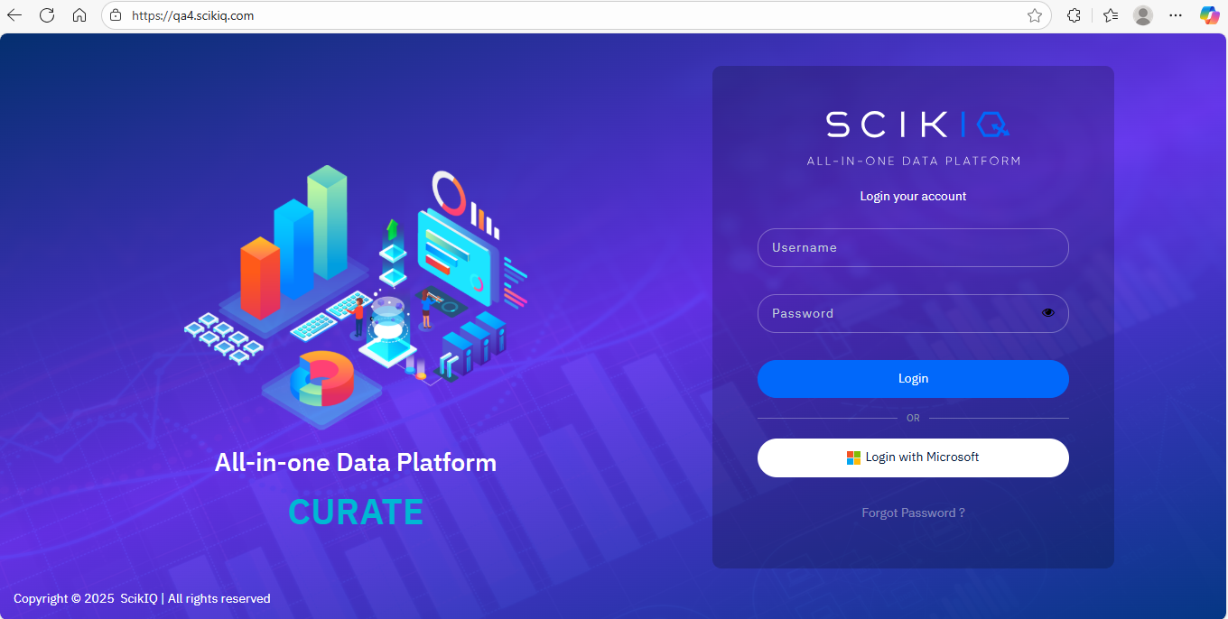
Step 2: Enter your username and password.
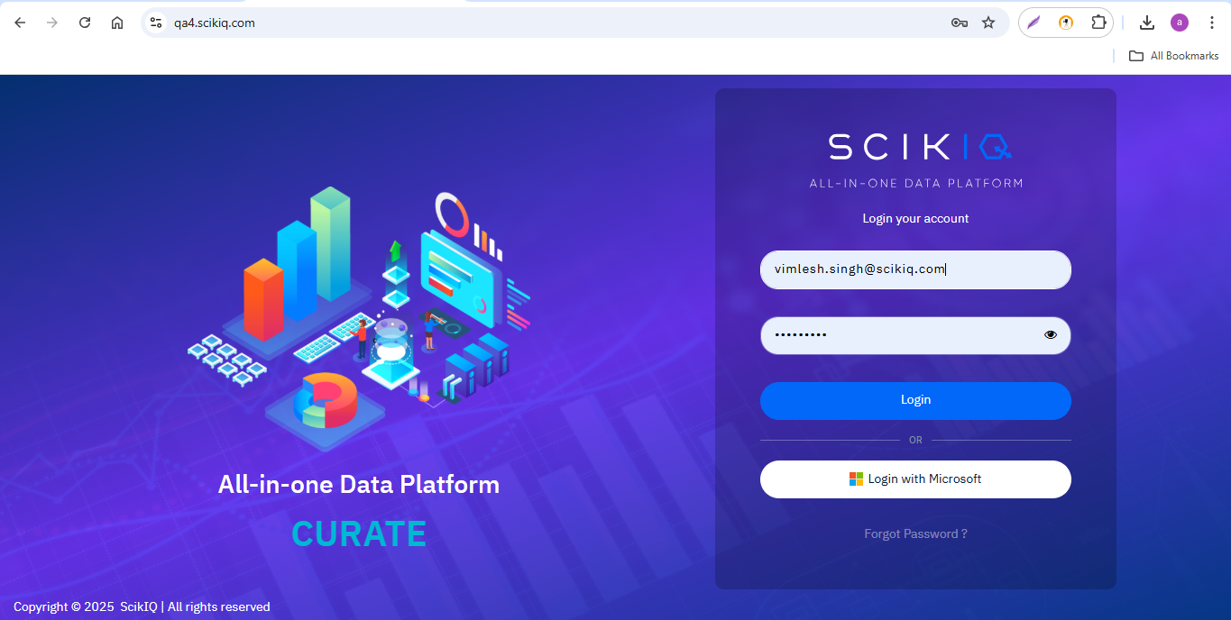
Step 3: Click Login to access the Home page.
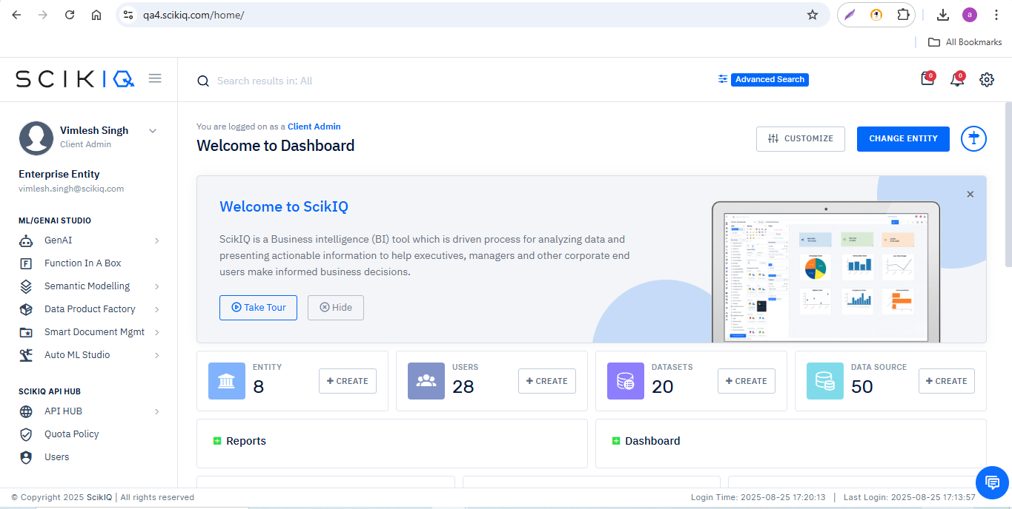

5.2 Navigate to Resource Section
1. From the left-side navigation panel, locate the resource category.
2. Select the relevant resource type: Datasources, ETLs, Schedulers, Datasets, LDMs, or Dashboards.

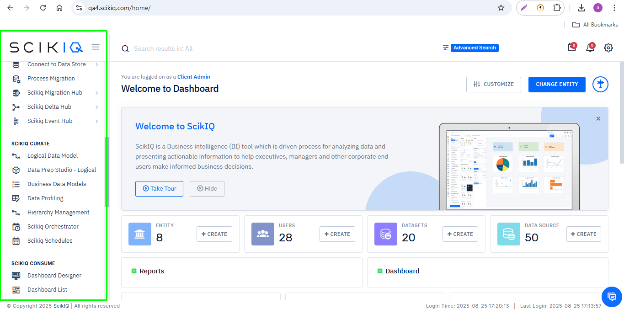

6. Restore Deleted Datasource
Detailed step-by-step process to restore deleted Datasources in the ScikIQ Platform.

6.1 Delete a Datasource
Step 1: Navigate to the resource listing page and select the desired resource type (e.g., Data source).
Step 2: Click on the list sub-menu. The page will display all connected/available resources.
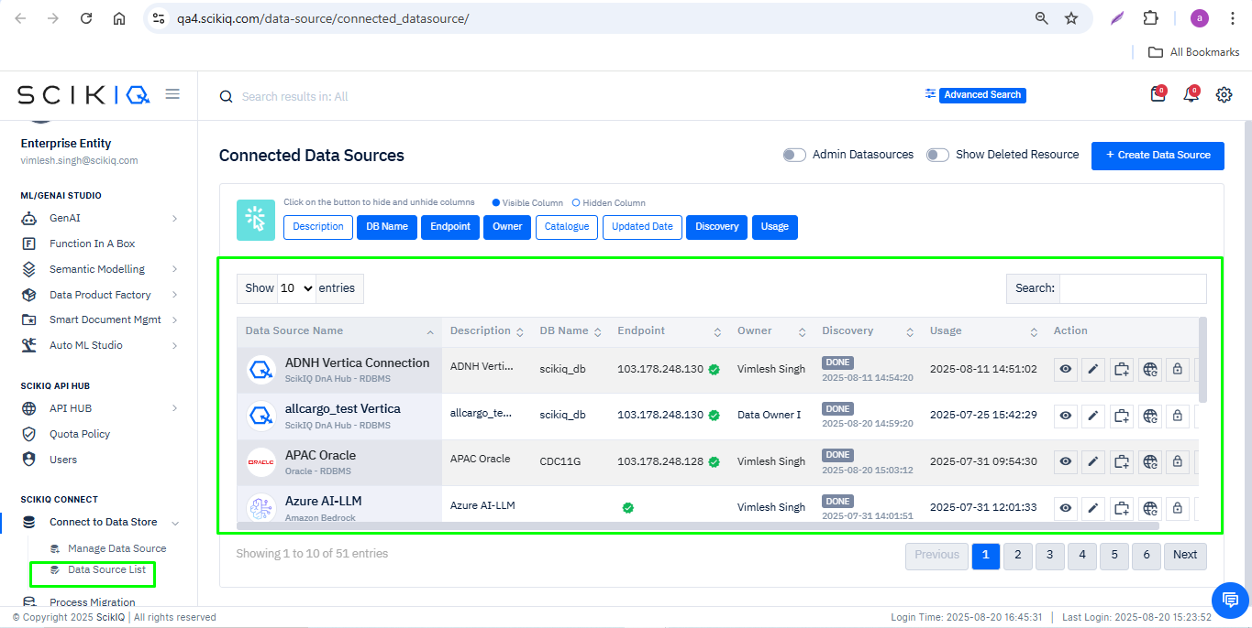
Step 3: Locate the Data source you want to delete and click on the Delete button in the Action column.
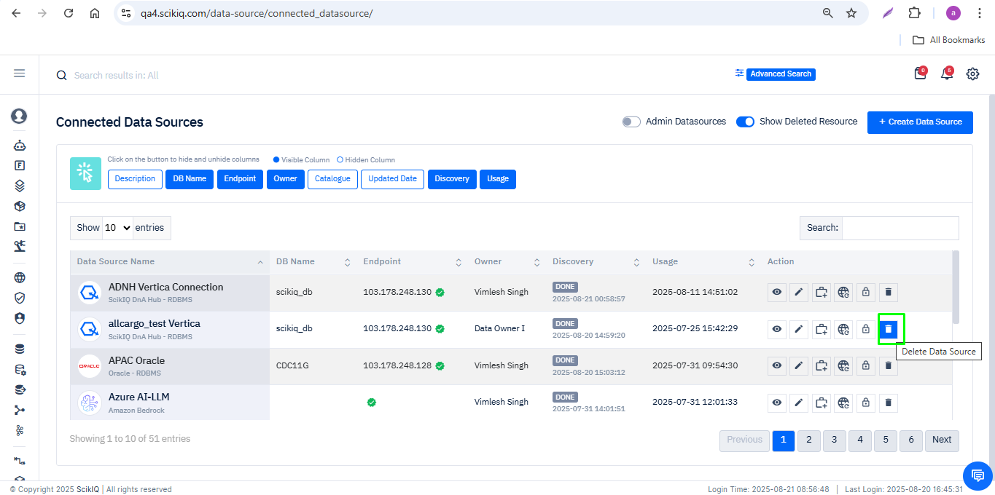
Step 4: A confirmation prompt will appear with the notification: “Are you sure you want to delete?”
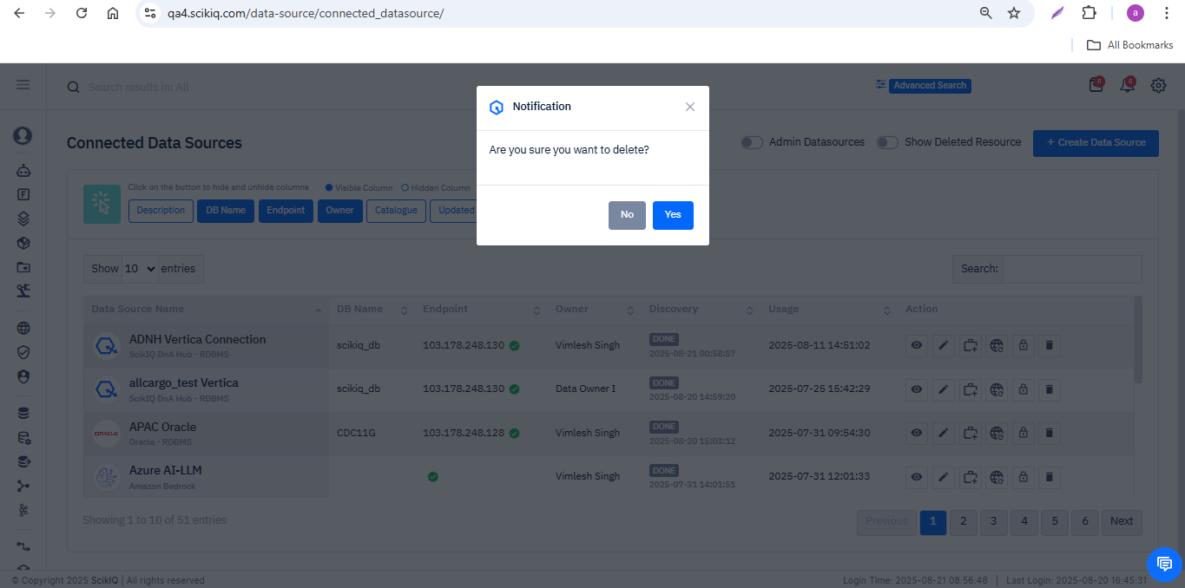
Step 5: Click Yes to confirm.
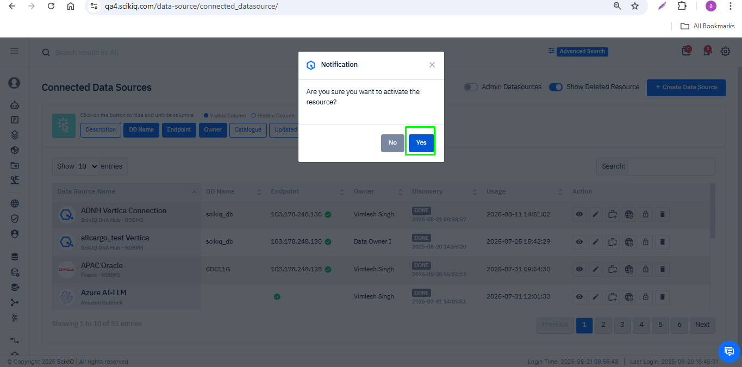
- The resource will be removed from the list.
- A flash message will appear: “SCIK-0173: Connection deleted successfully.”
- The total count of resources will decrease as the resource is deleted.

.

6.2 Display Deleted Datasources
Step 1: On the resource listing page, go to the top-right corner and locate the toggle Show Deleted Resource.
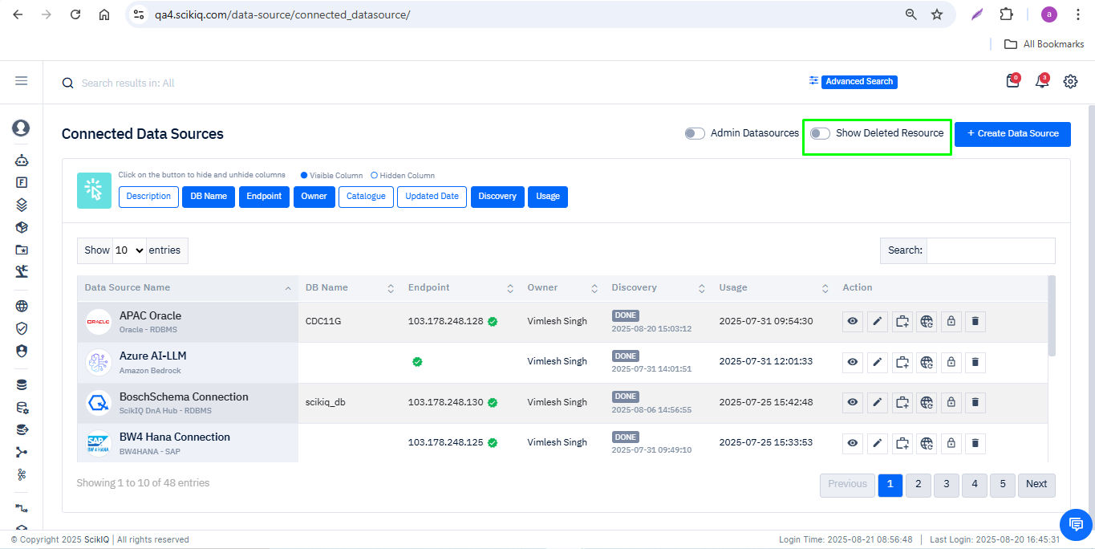
Step 2: Enable the toggle.
- The page will refresh automatically.
- Deleted resources will now be visible in the list.
- These deleted resources are highlighted in a different style (e.g., grayed-out entries or red-highlighted rows) to distinguish them from active resources.
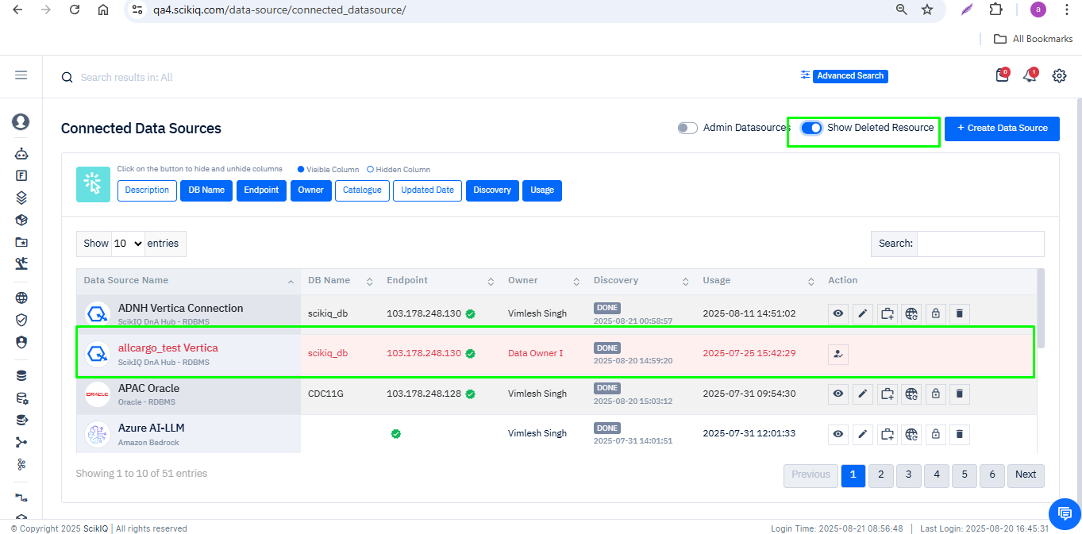

2. Deleted resources will be visible in a distinct style (e.g., highlighted in red).

6.3 Restore Deleted Datasource
Step 1. Locate the deleted Datasource in the list.
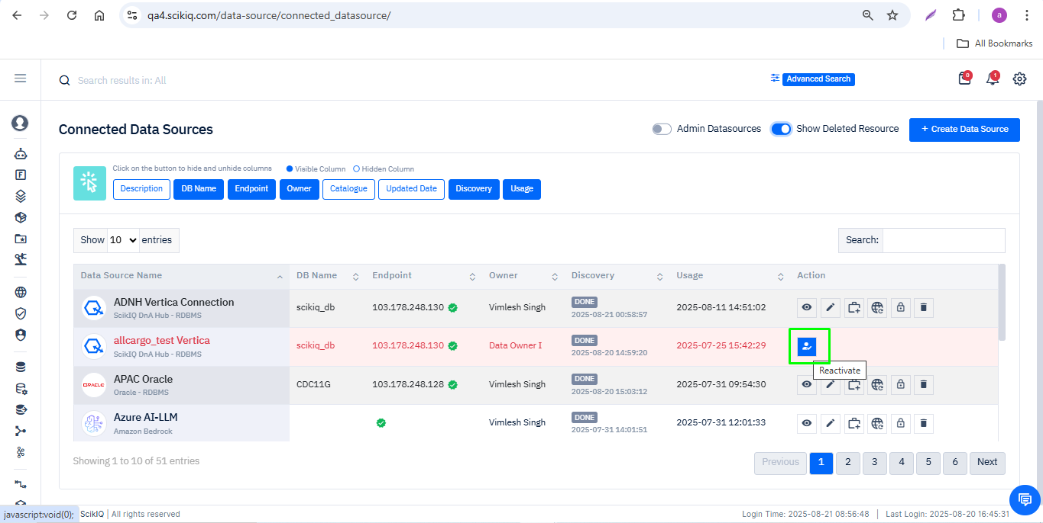
Step 2. Click the Restore/Reactivate button.
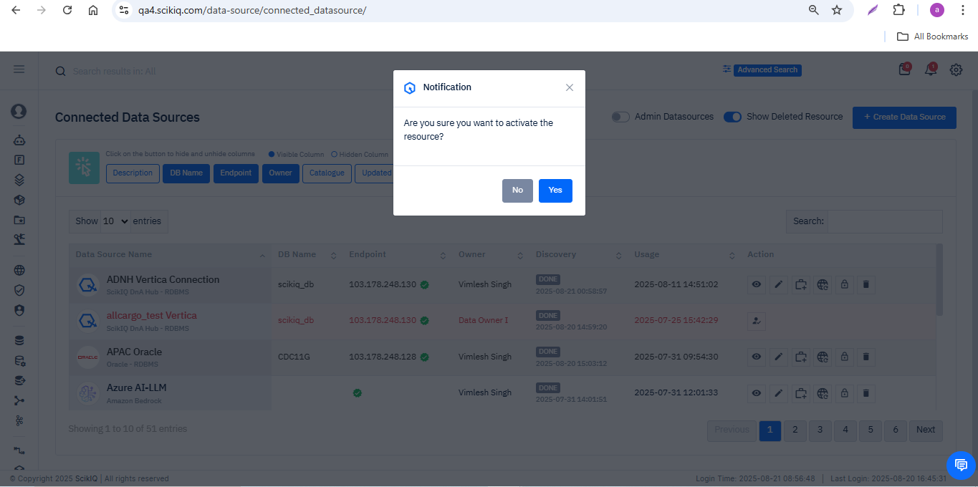
Step 3: Confirm restoration. A success notification will appear.
The restored Datasource will now be available in the active resource list.
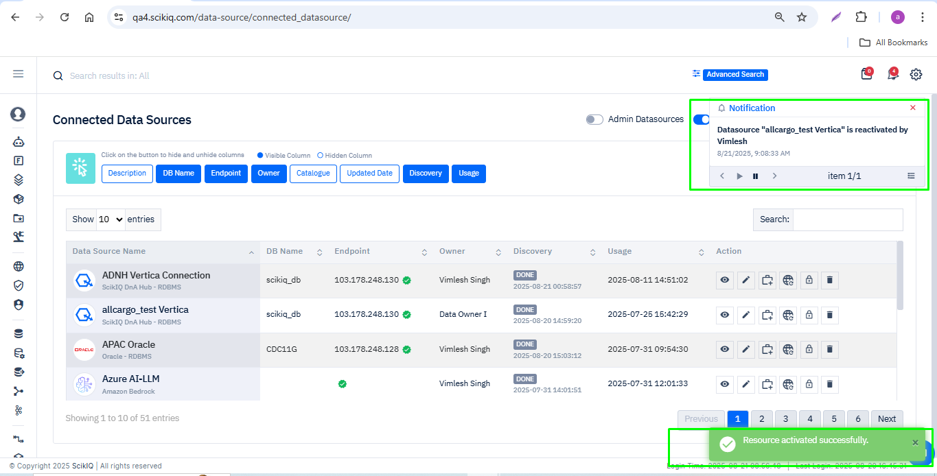

6.4 Special Considerations for Datasource Restoration
• Validate connection details and credentials after restoration..
• Sharing/permissions are removed upon deletion; they must be re-applied manually..

7. Restore Deleted ETL Pipeline
Detailed step-by-step process to restore deleted ETL Pipelines in the ScikIQ Platform.

7.1 Delete a ETL Pipeline
Step 1. Navigate to the ETL Pipeline listing page.
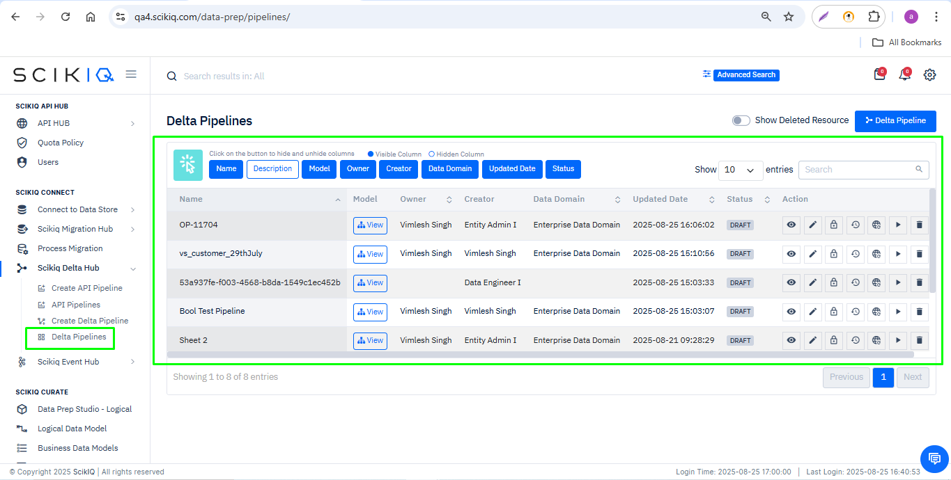
Step 2. Select the ETL Pipeline you want to delete and click Delete button in the Action column.
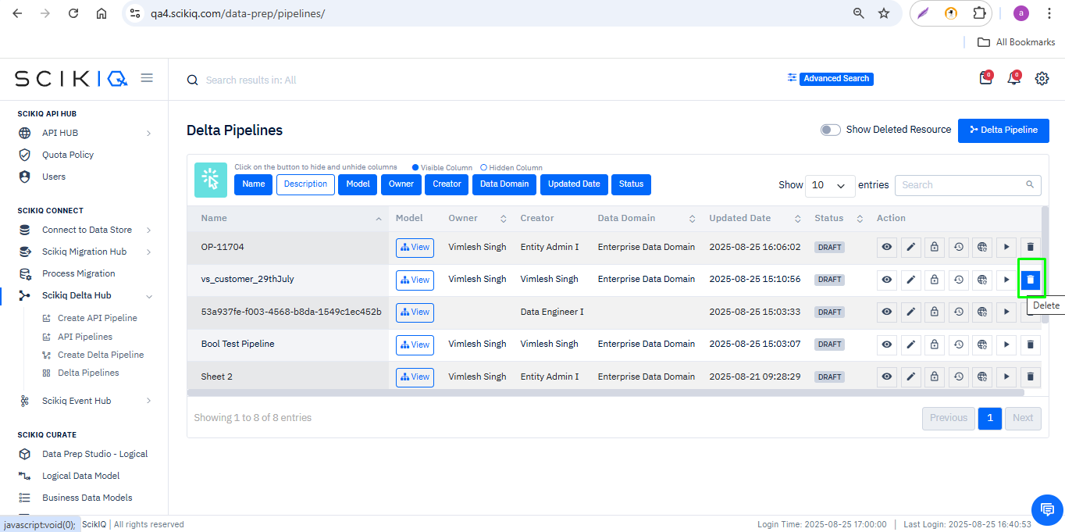
Step 3: A confirmation prompt will appear with the notification: “Are you sure you want to delete?”
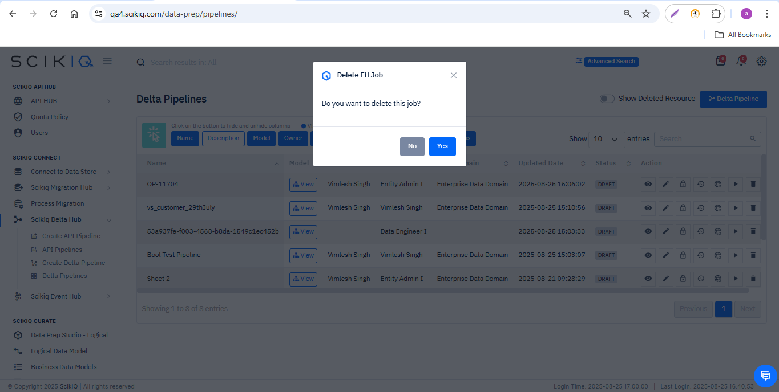
Step 4: Click Yes to confirm.
- The ETL pipeline will be removed from the active list.
- A flash message will appear: “ETL pipeline deleted successfully.”
- The total count of ETL resources will decrease.
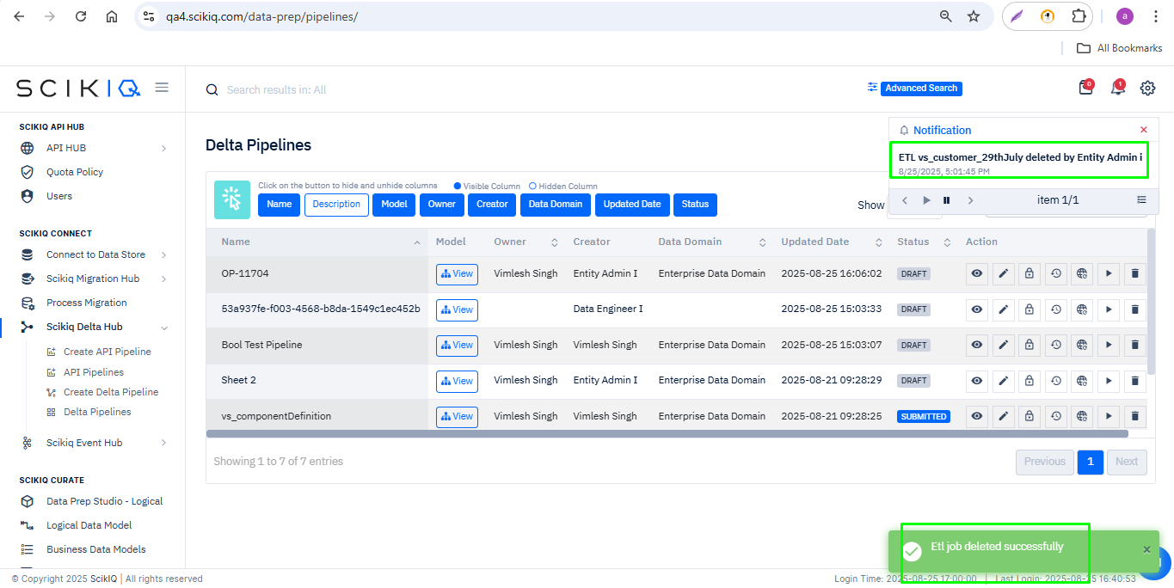

7.2 Display Deleted ETL Pipelines
Step 1: On the resource listing page, enable the 'Show Deleted Resource' toggle.
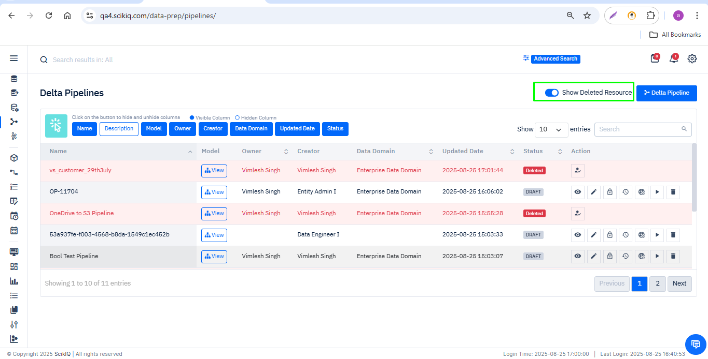
Step 2. Deleted resources will be visible in a distinct style (e.g., highlighted in red).
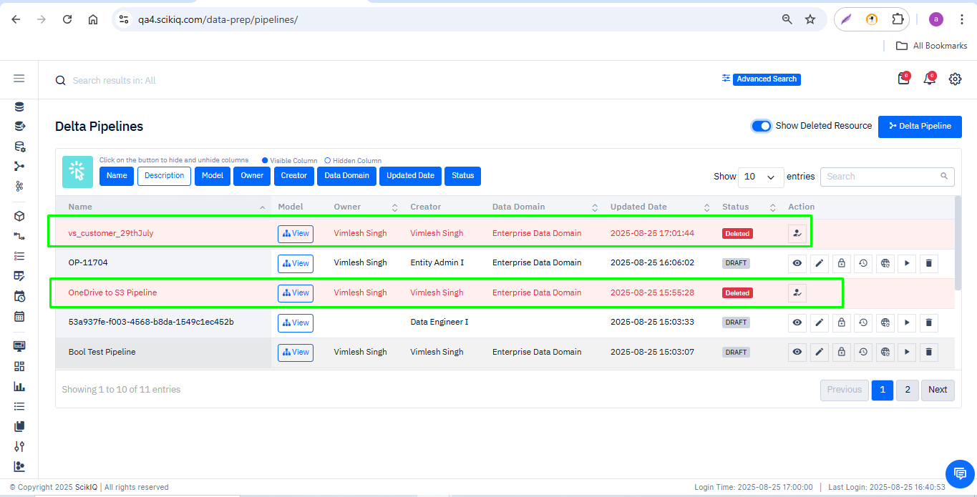

7.3 Restore Deleted ETL Pipeline
Step 1: Scroll through or use the search option to find the deleted ETL pipeline you want to restore.
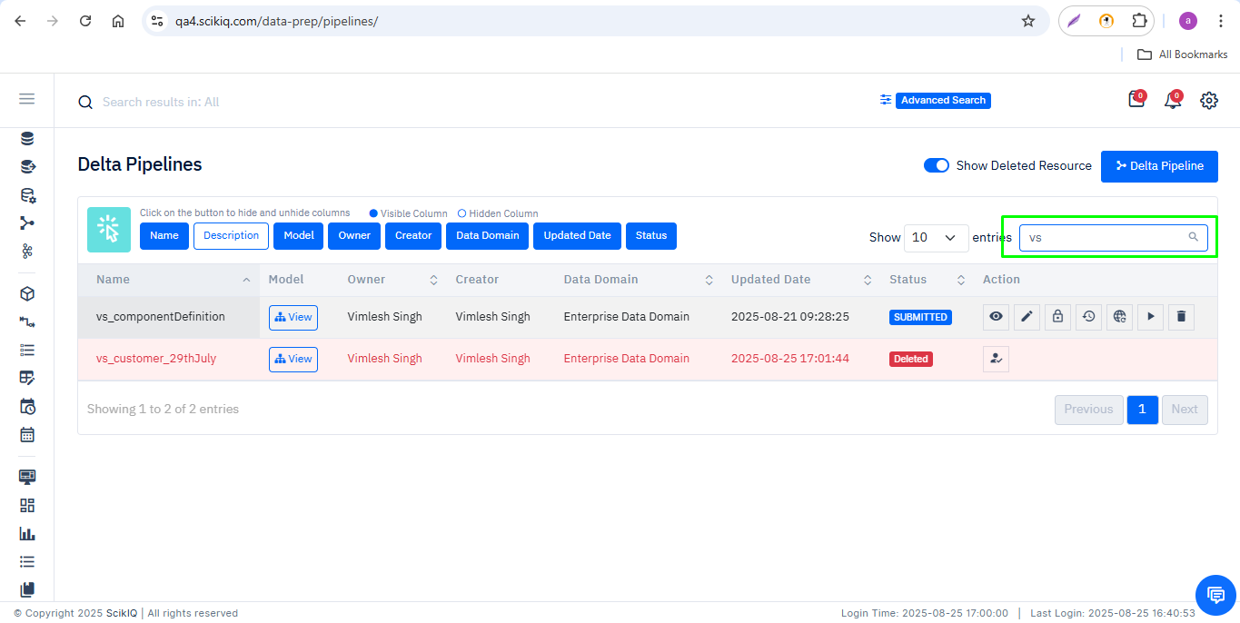
Step 2: In the Action column, a new button appears for deleted ETL resources -the Restore (or Reactivate) button with a reactivation icon.
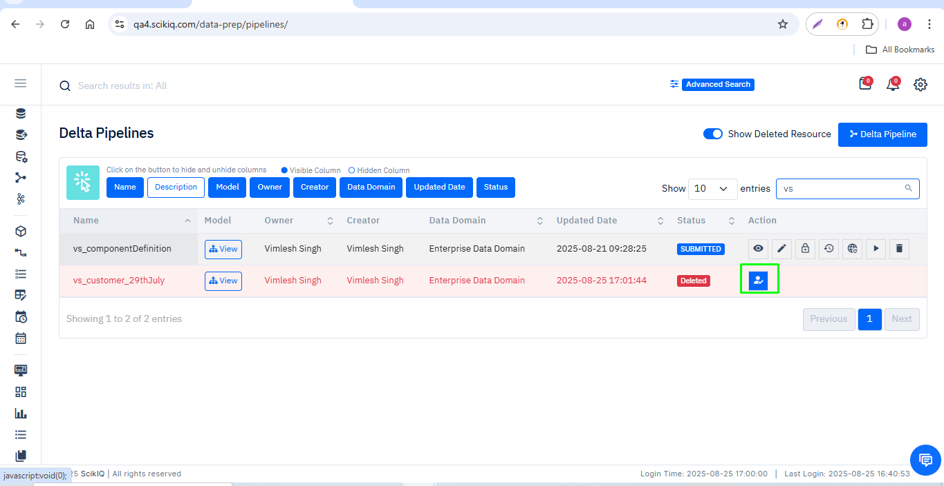
Step 3: Click on the Restore button. Review the details and click Yes (or confirm) to proceed.
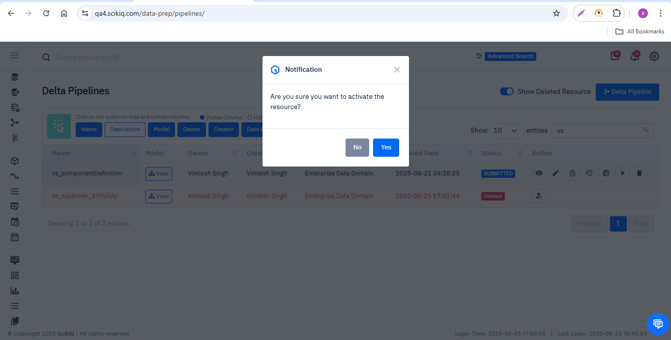
Step 5: A success notification will be displayed:
- Flash message: “ETL pipeline activated successfully.”
- A notification pop-up will also appear on the screen.
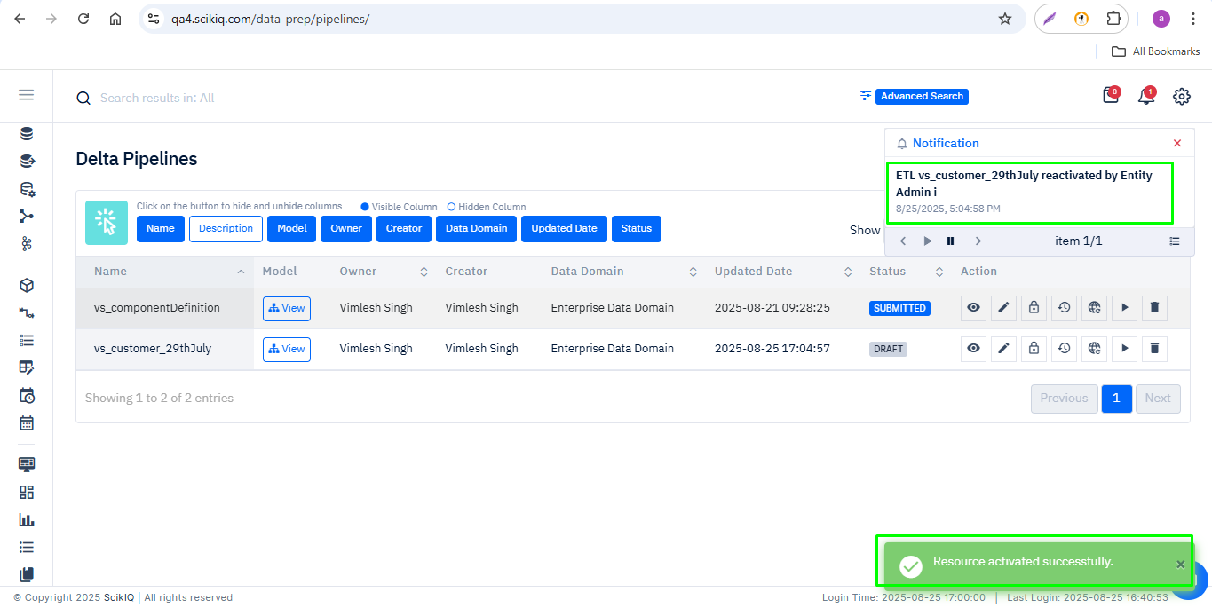
Step 6: The restored ETL pipeline will now reappear in the active resource list. You can now use, edit, and configure it as required.
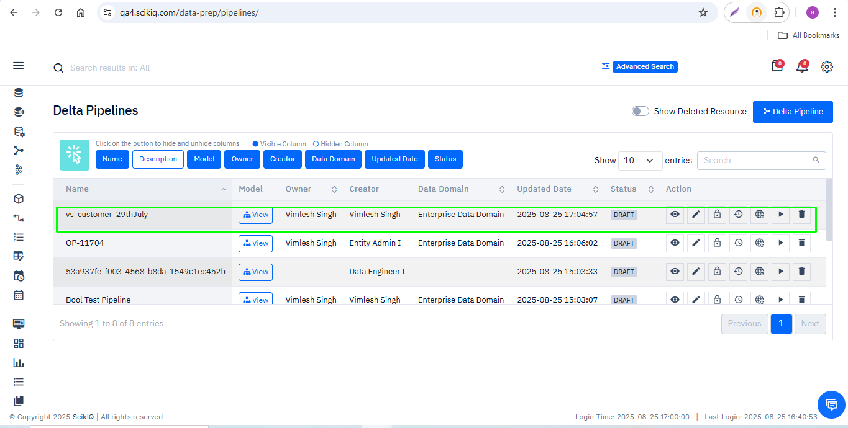

7.4 Special Considerations for ETL Pipeline Restoration
- If the restored ETL pipeline has dependencies on other resources (such as datasets, data sources, or schedulers), verify that those linked resources are also active and available.
- Review ETL steps, mappings, and configuration after restoration..
- Edit or revalidate the ETL before using it.
- All restoration actions are logged for audit purposes. Only authorized roles may perform restoration.
- If the ETL pipeline was previously scheduled or linked to triggers, confirm its schedule and re-link as needed.
- Note: Permissions are not restored automatically. You must grant them again manually.

8. Restore Deleted Scheduler
Detailed step-by-step process to restore deleted Schedulers in the ScikIQ Platform.

8.1 Delete a Scheduler
Step 1. Navigate to the Scheduler listing page.
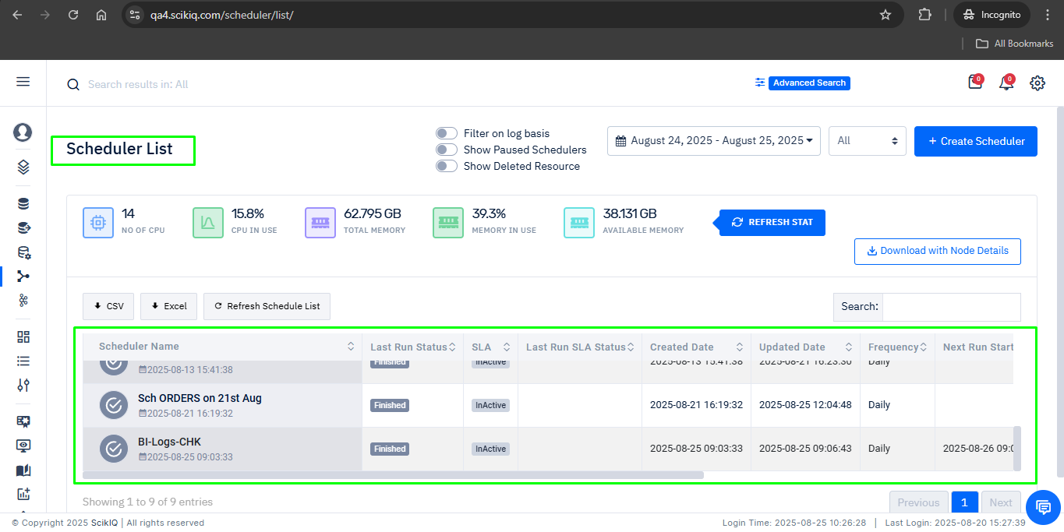
Step 2. Select the Scheduler you want to delete and click Delete.
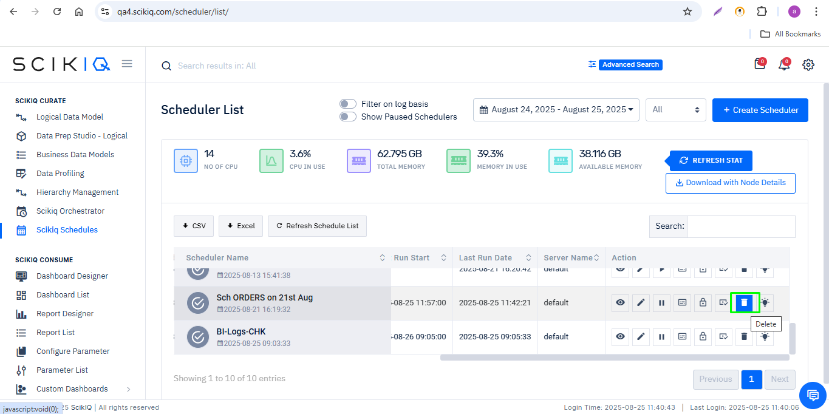
Step 3: A confirmation prompt will appear: “Are you sure you want to delete?”
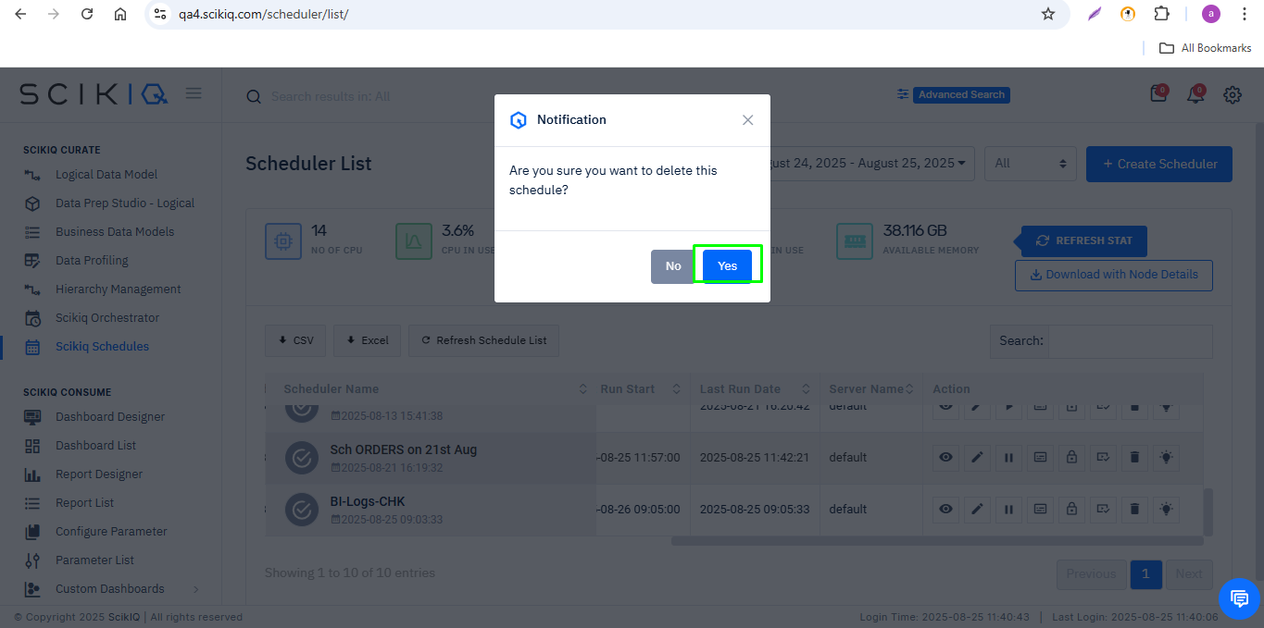
Step 4: Click Yes to confirm.
- The Scheduler will be removed from the active list.
- A flash message will appear: “SCIK-0038: schedule removed.”
- The total count of Schedulers will decrease.
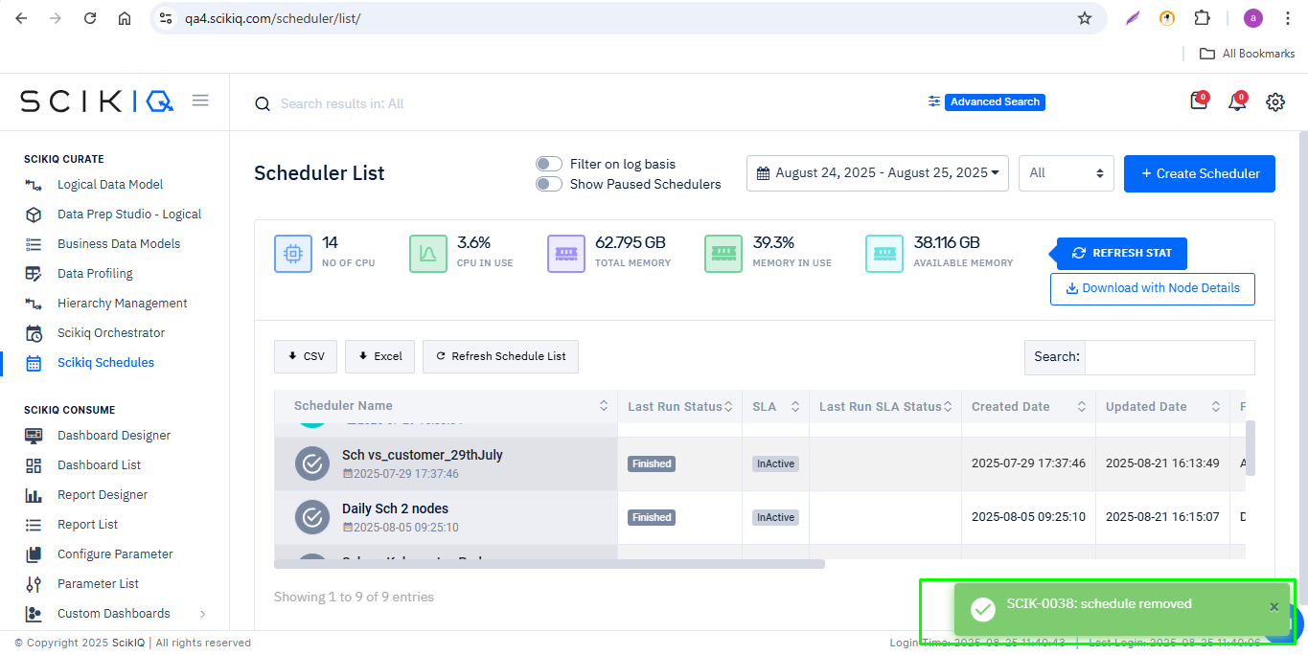

8.2 Display Deleted Schedulers
Step 1: On the resource listing page, enable the 'Show Deleted Resource' toggle. Deleted resources will be visible in a distinct style (e.g., highlighted in red).
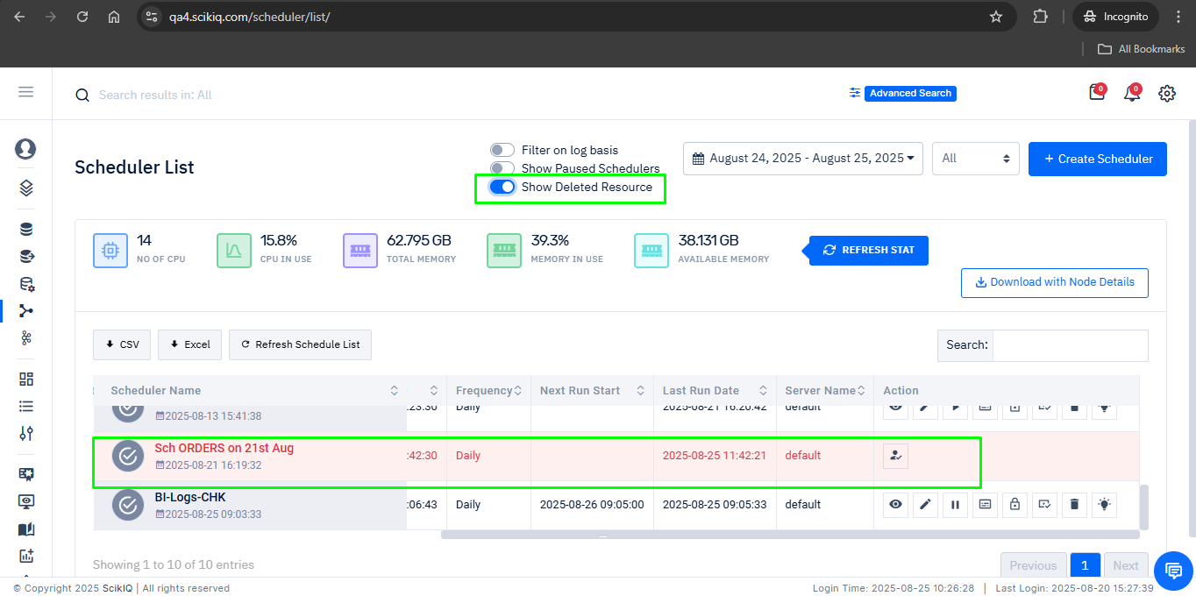

8.3 Restore Deleted Scheduler
Step 1. Locate the deleted Scheduler in the list.
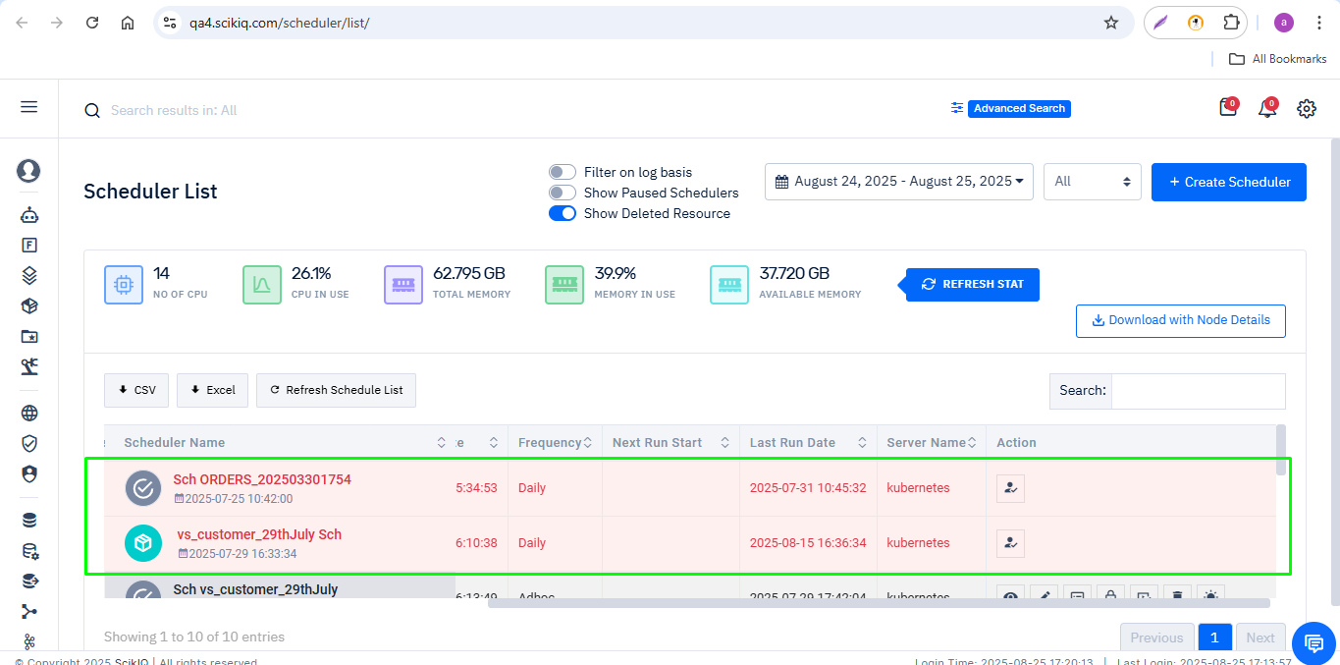
Step 2. Click the Restore/Reactivate button.
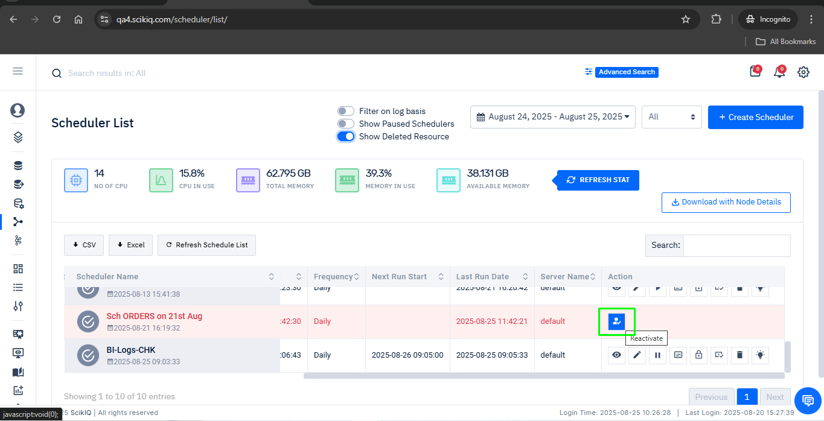
Step 3: Click yes to confirm delete.

A success notification will be displayed:
- Flash message: “Scheduler activated successfully.”
- A notification pop-up 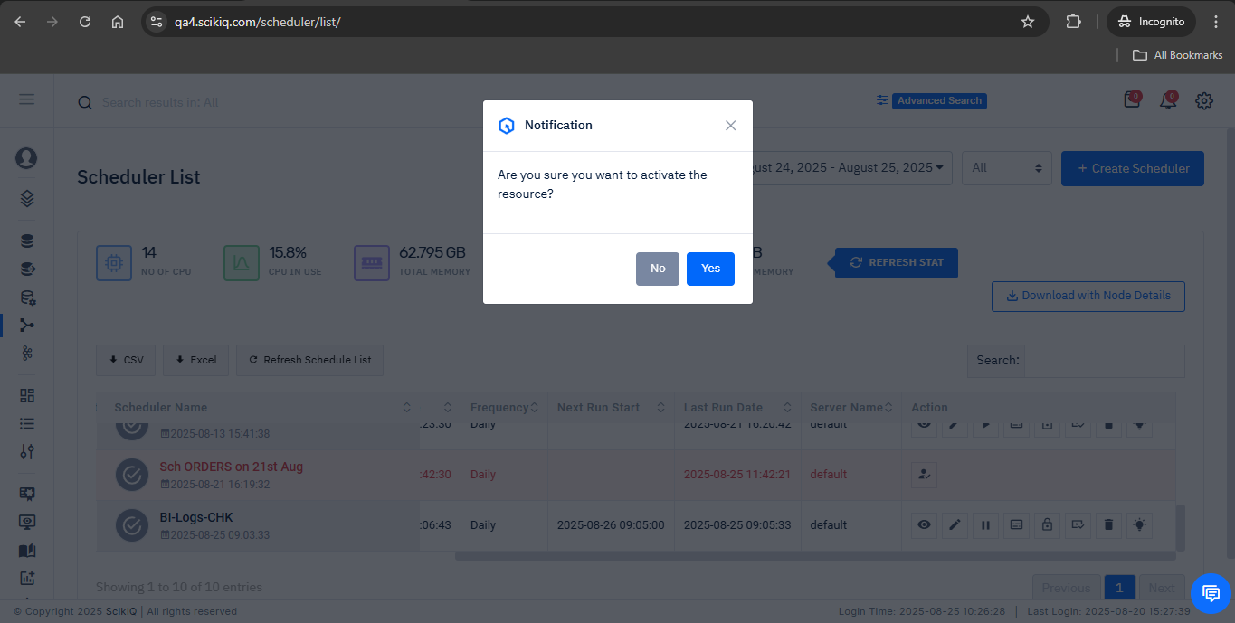will also appear on the screen.
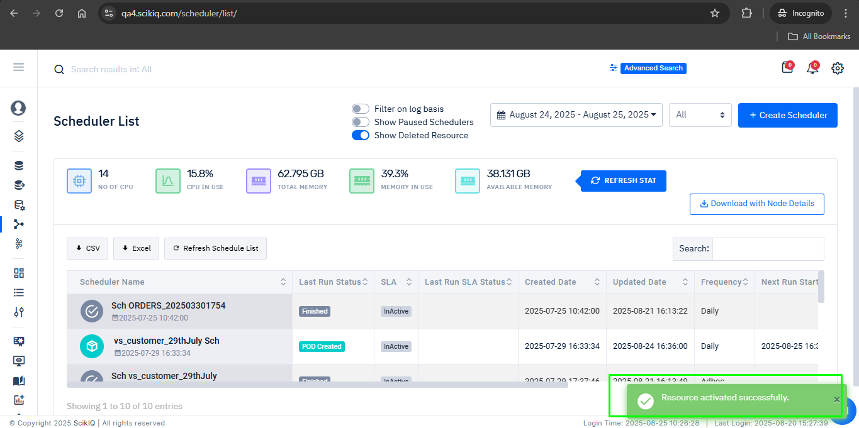
Step 7: The restored Scheduler will now reappear in the active resource list. You can now use, edit, and configure it as required.
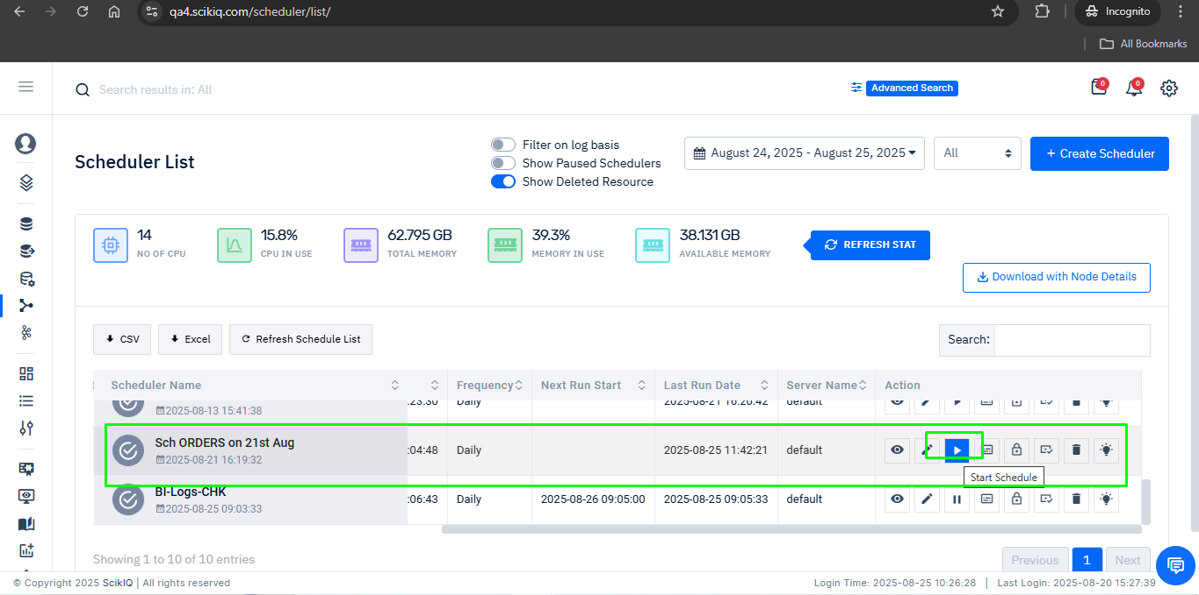

8.4 Important Note- Post Restoration status
After restoration, the Scheduler status will be set to Paused by default, and the Next Run Start Date will be blank.
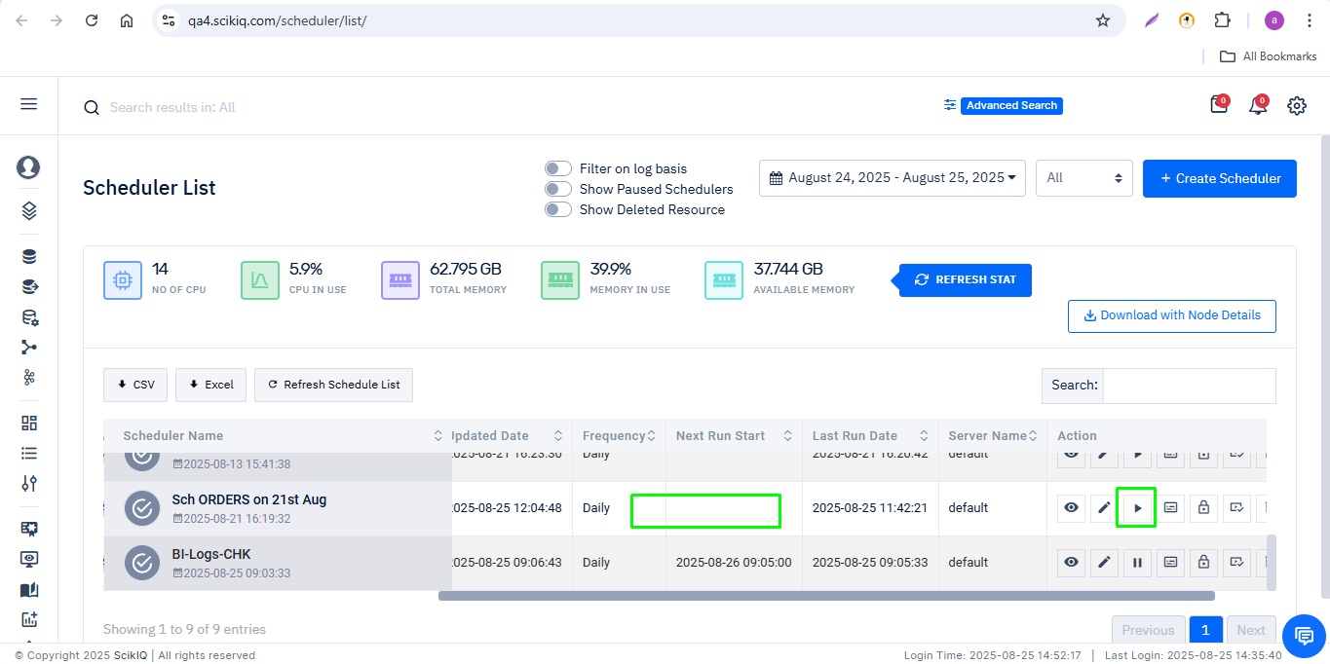
To start the Scheduler: Click the Edit button on the restored Scheduler.
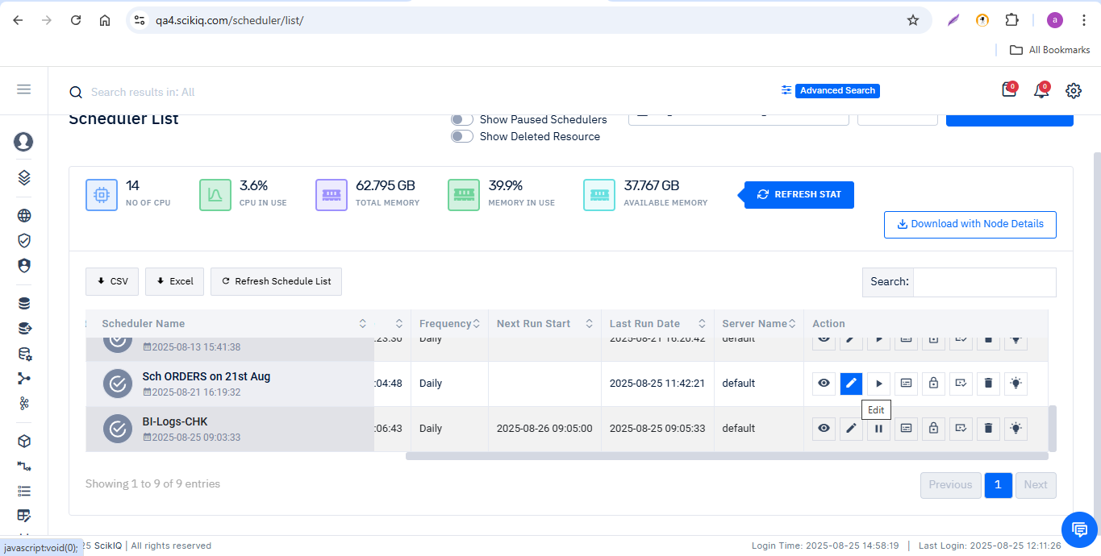
Make necessary updates (if any) and click Next.
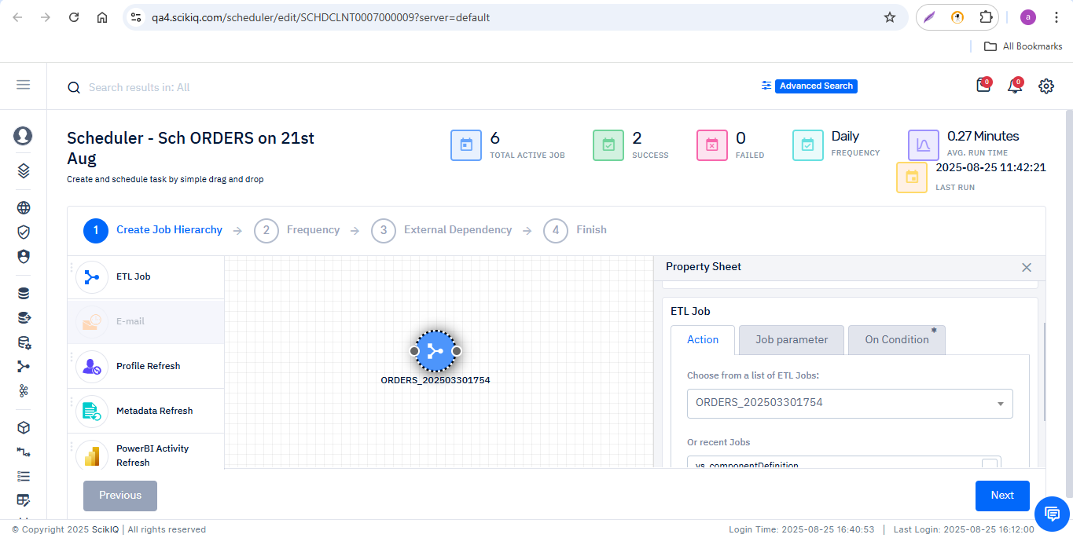
Set the Start Date and Time.
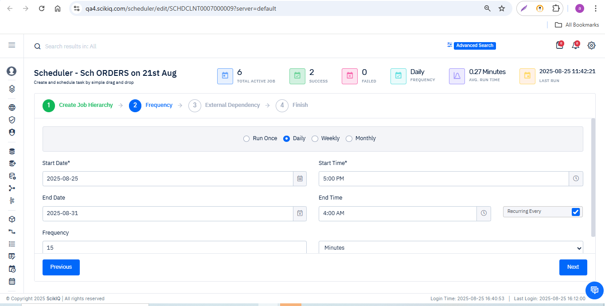

Click Finish to start the Scheduler.
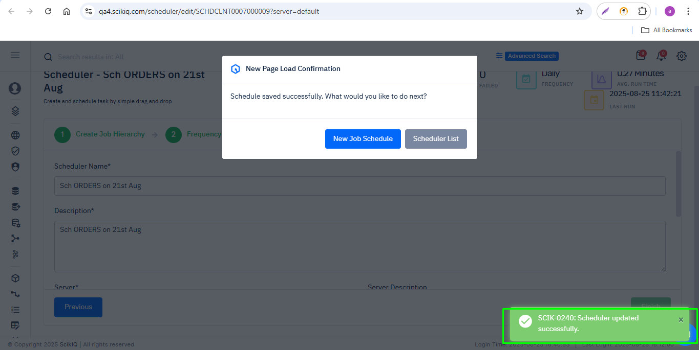
The Scheduler will now run at the configured start time and date.
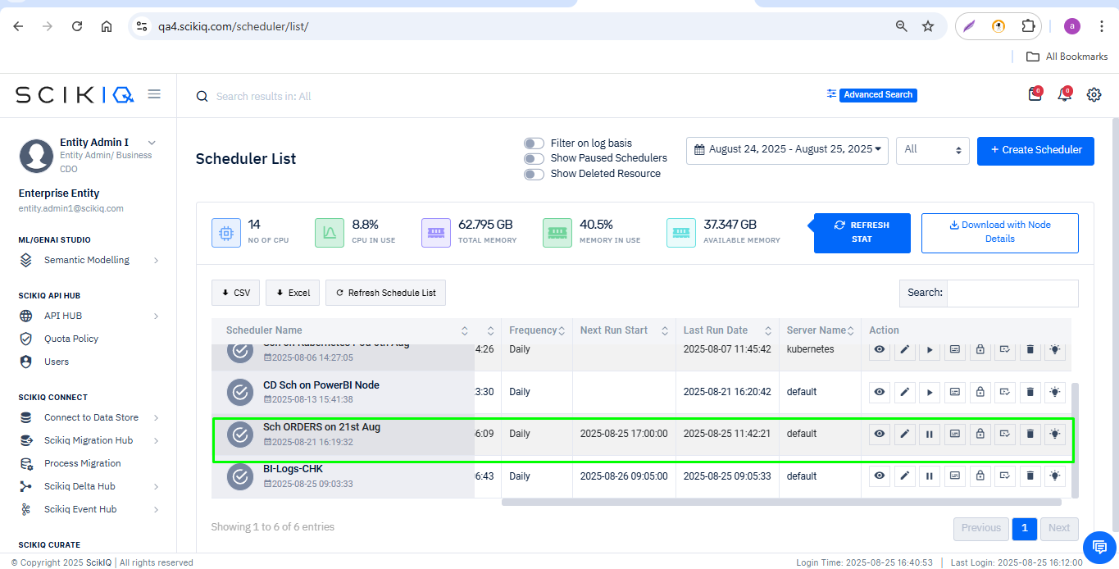

8.5 Special Considerations for Scheduler Restoration
- After restoring a Scheduler, edit and save the configuration before it can run.
- Verify that dependent resources (ETLs, datasets, data sources) are active.
- All restoration actions are logged and only authorized roles can perform them.
- The Scheduler may need configuration updates based on dependencies.
- Note: Permissions are not restored automatically; they must be granted again manually.

9. Restore Deleted Logical Data Model (LDM)
Detailed step-by-step process to restore deleted Logical Data Model (LDM)s in the ScikIQ Platform.

9.1 Delete a Logical Data Model (LDM)
Step 1: Navigate to the Logical Data Model (LDM) listing page.
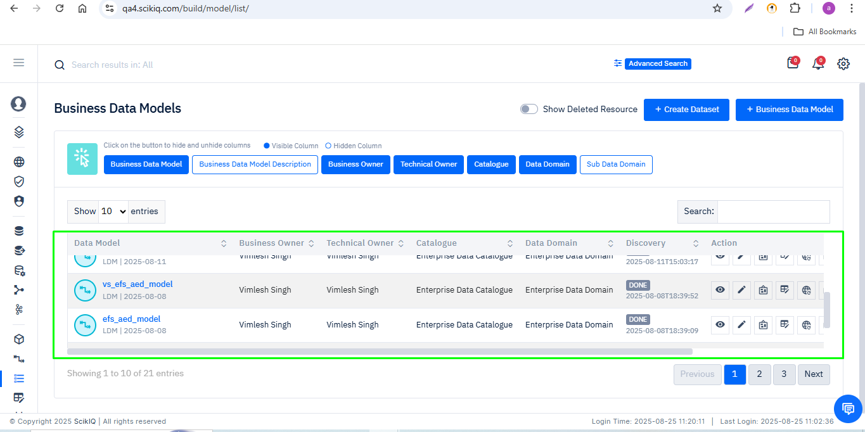
Step 2. Select the Logical Data Model (LDM) you want to delete and click Delete.
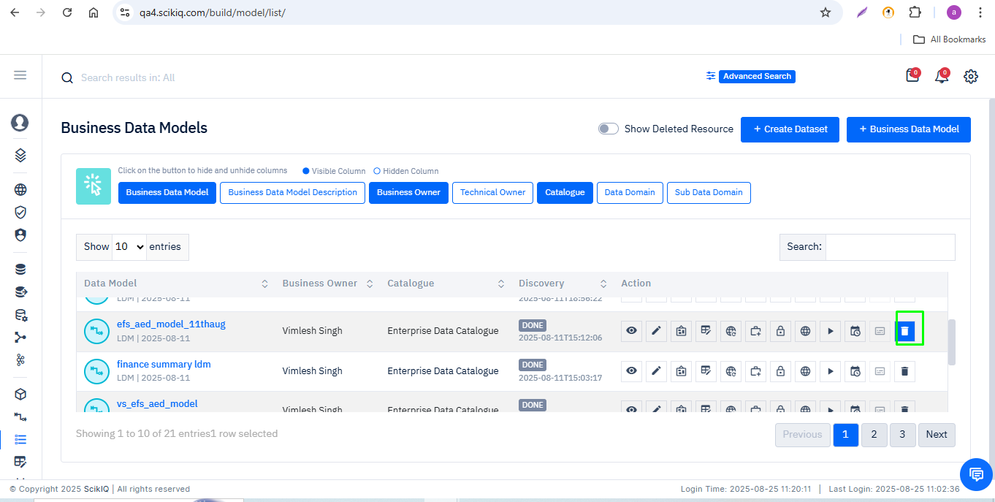
Step 3: A confirmation prompt will appear with the notification: “Are you sure you want to delete?”
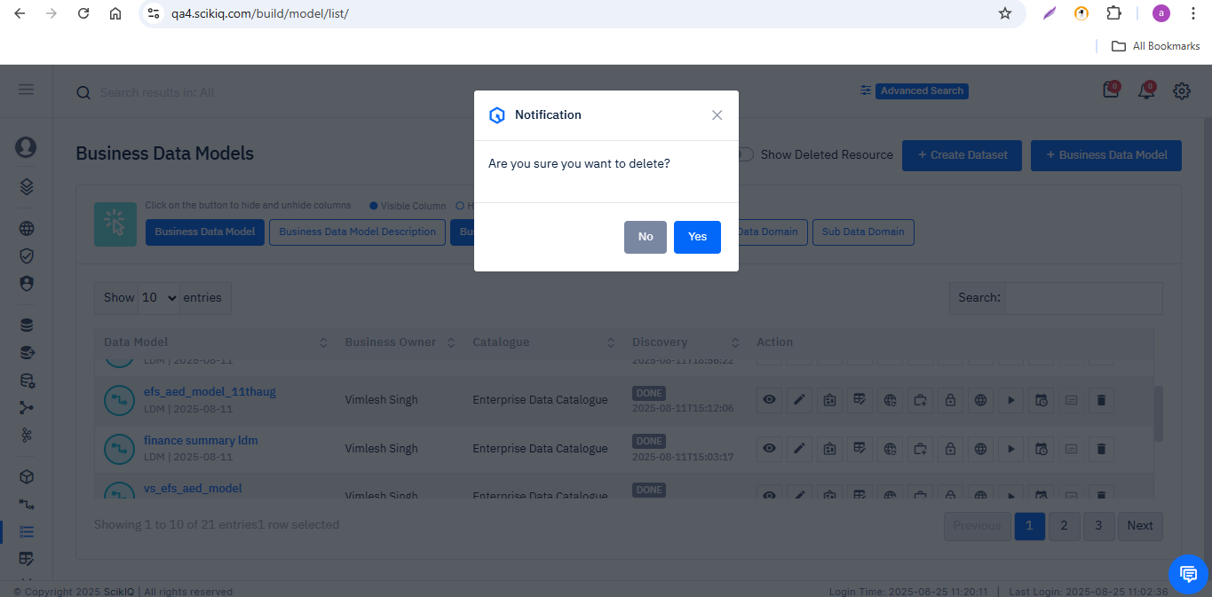
Step 5: Click Yes to confirm.
- The LDM will be removed from the active list.
- A flash message will appear: “SCIK-0173: LDM deleted successfully.”
- The total count of LDM resources will decrease.
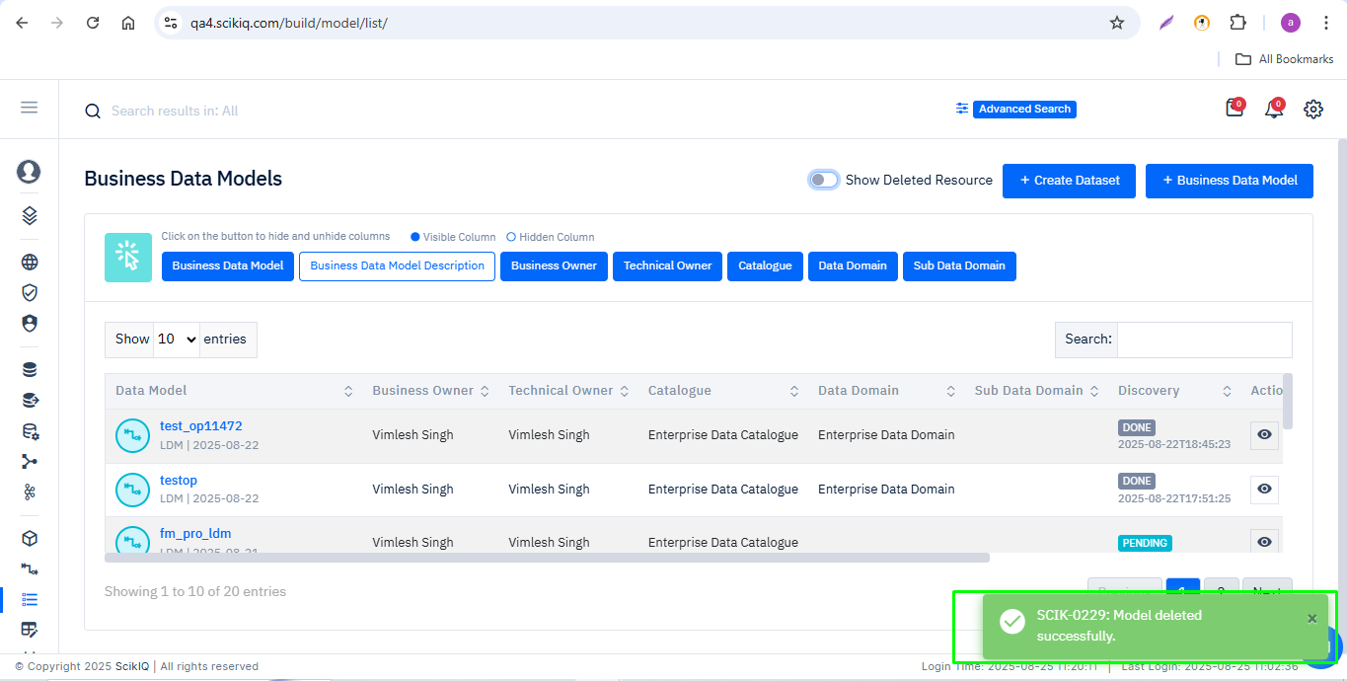

9.2 Display Deleted Logical Data Model (LDM)s
Step 1. On the resource listing page, enable the 'Show Deleted Resource' toggle
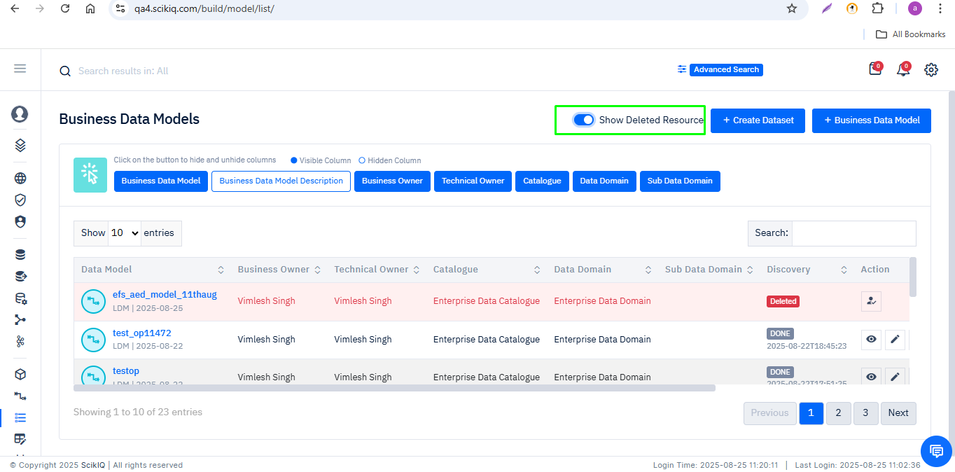
Step 2: Deleted LDMs will now be visible in the list. These deleted resources are highlighted in a different style (e.g., highlighted in red) to distinguish them from active resources.
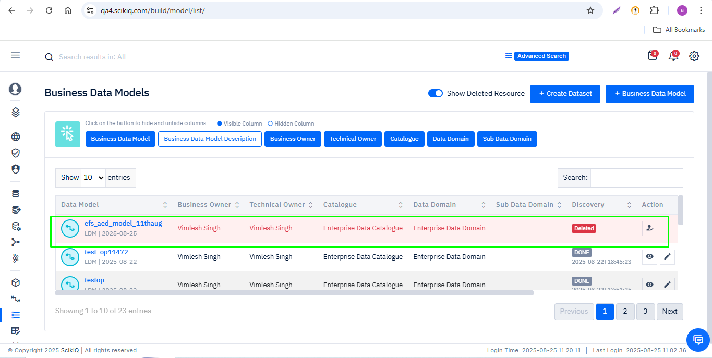

9.3 Restore Deleted Logical Data Model (LDM)
Step 1. Locate the deleted Logical Data Model (LDM) in the list.
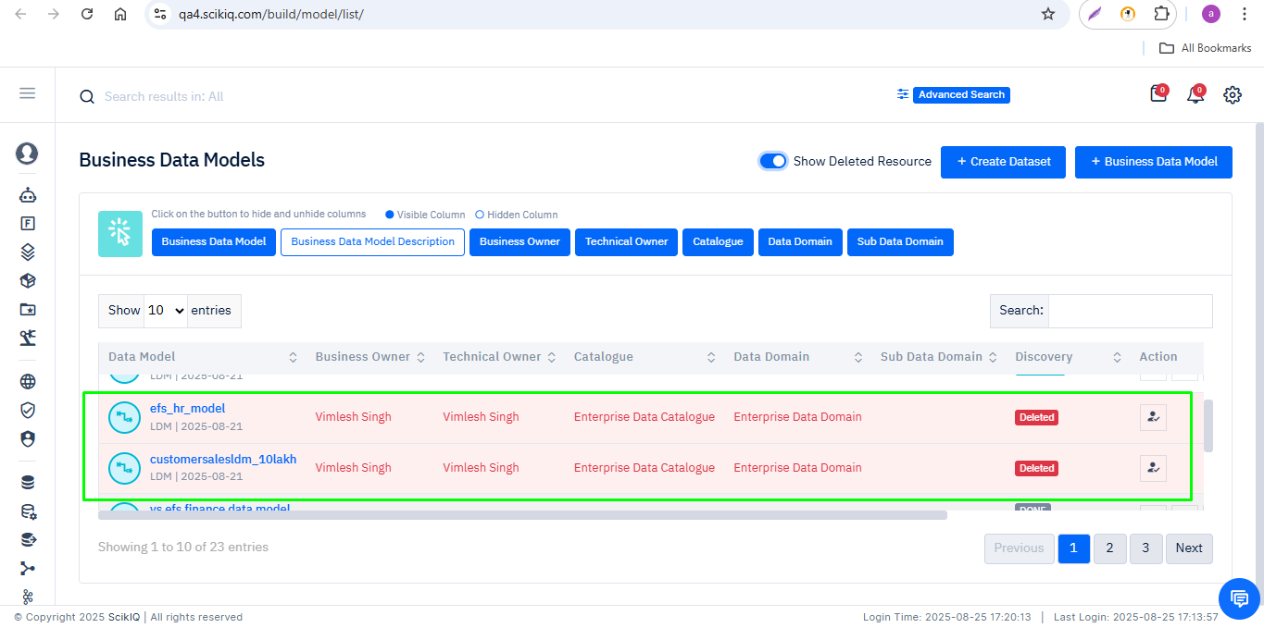
Step 2: Click on the Restore button.
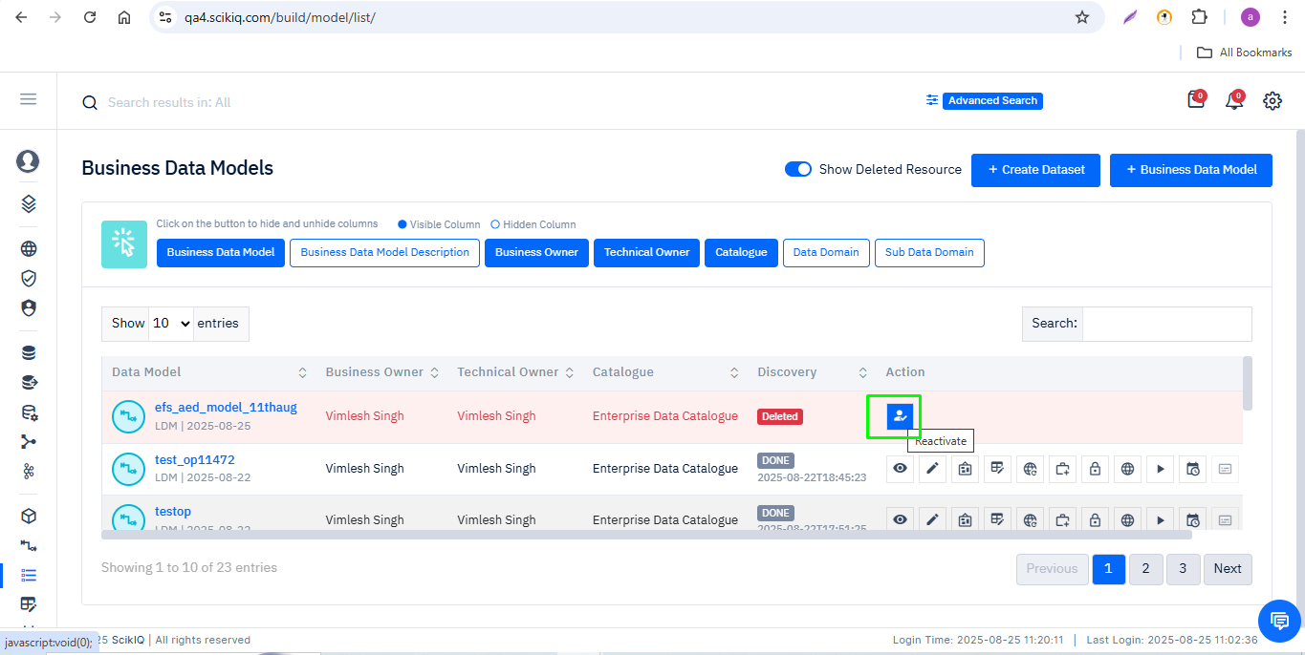
Step 3: Click Yes to confirm.
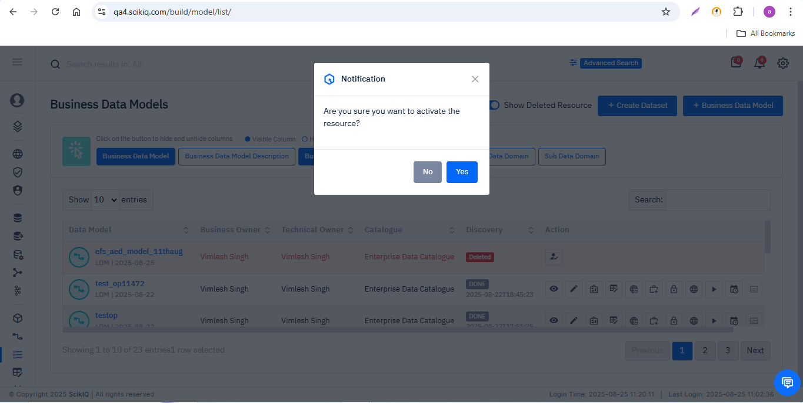
Step 4: A success notification will be displayed:
- Flash message: “LDM activated successfully.”
- A notification pop-up will also appear on the screen.
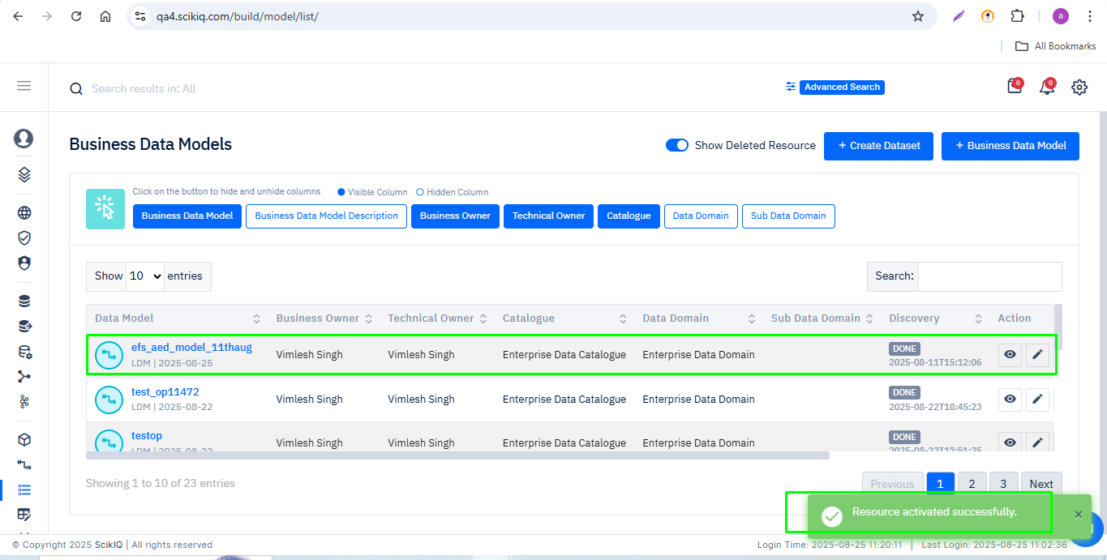
Step 5: The restored LDM will now reappear in the active resource list. You can now use, edit, and configure it as required.
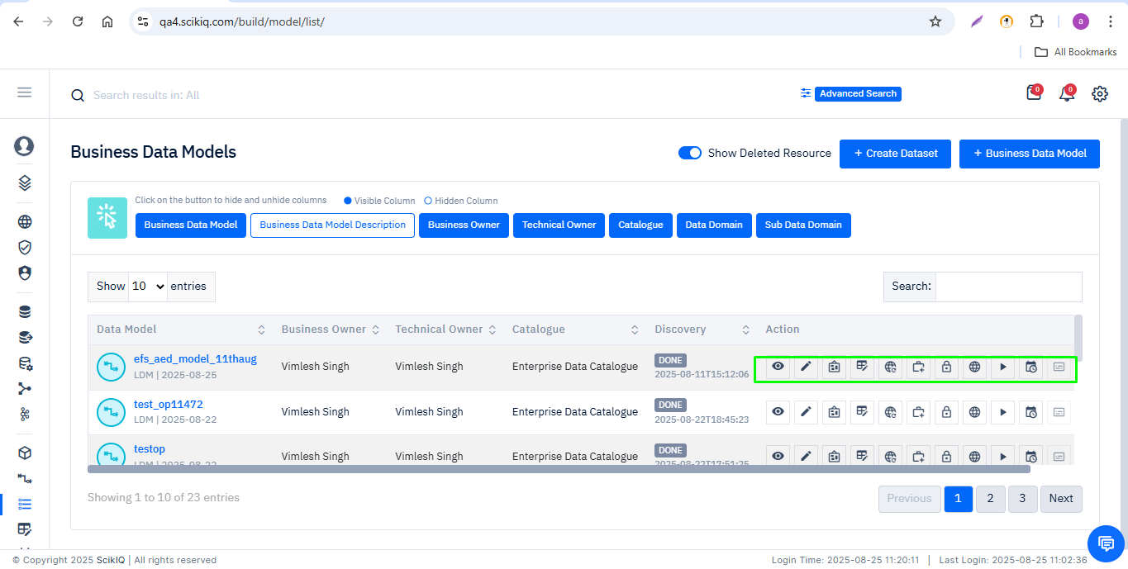

9.4 Special Considerations for Logical Data Model (LDM) Restoration
- If the restored LDM has dependencies on other resources (such as datasets, data sources, or ETLs), verify that those linked resources are also active and available.
- Review the LDM configuration to confirm mappings and relationships are correct.
- You may need to edit or revalidate the restored LDM for its intended business use.
- All restoration actions are logged for audit purposes. Only authorized roles may perform restoration.
- If the LDM was previously integrated into any dashboards or reports, confirm its status and re-link as needed.

10. Restore Deleted Dashboard
Detailed step-by-step process to restore deleted Dashboards in the ScikIQ Platform.

10.1 Delete a Dashboard
Step 1. Navigate to the Dashboard listing page.
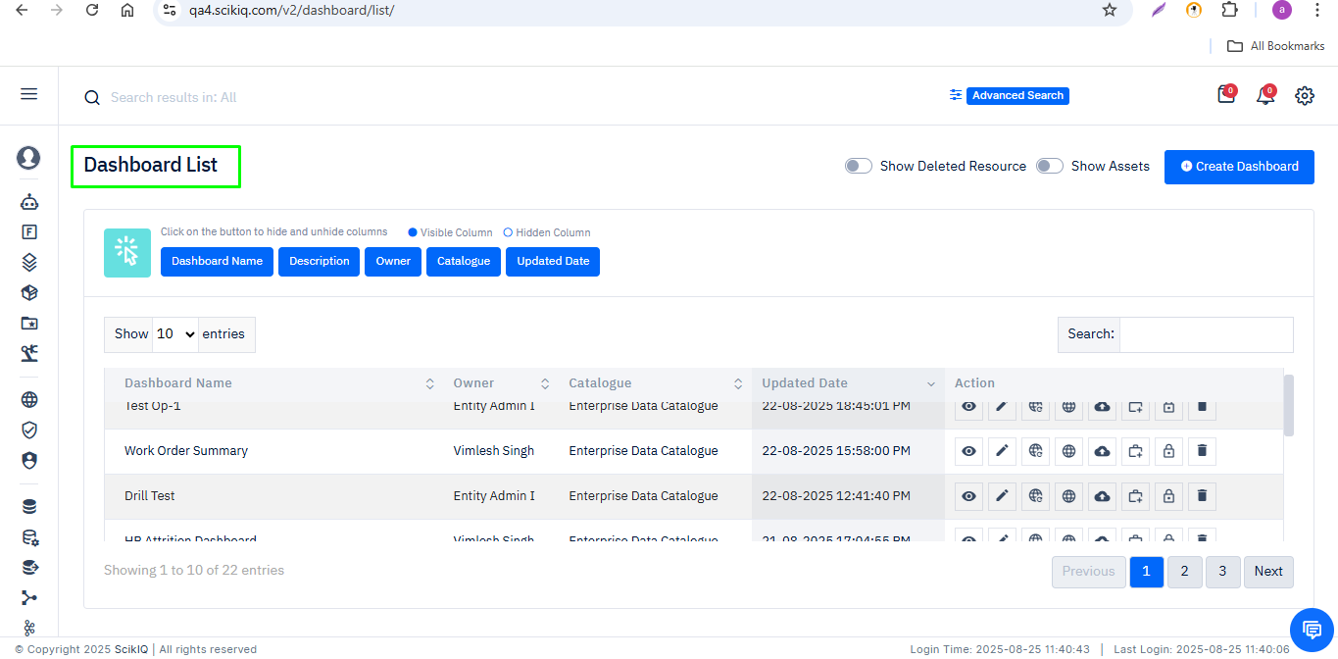
Step 2: Select the Dashboard you want to delete and click Delete.
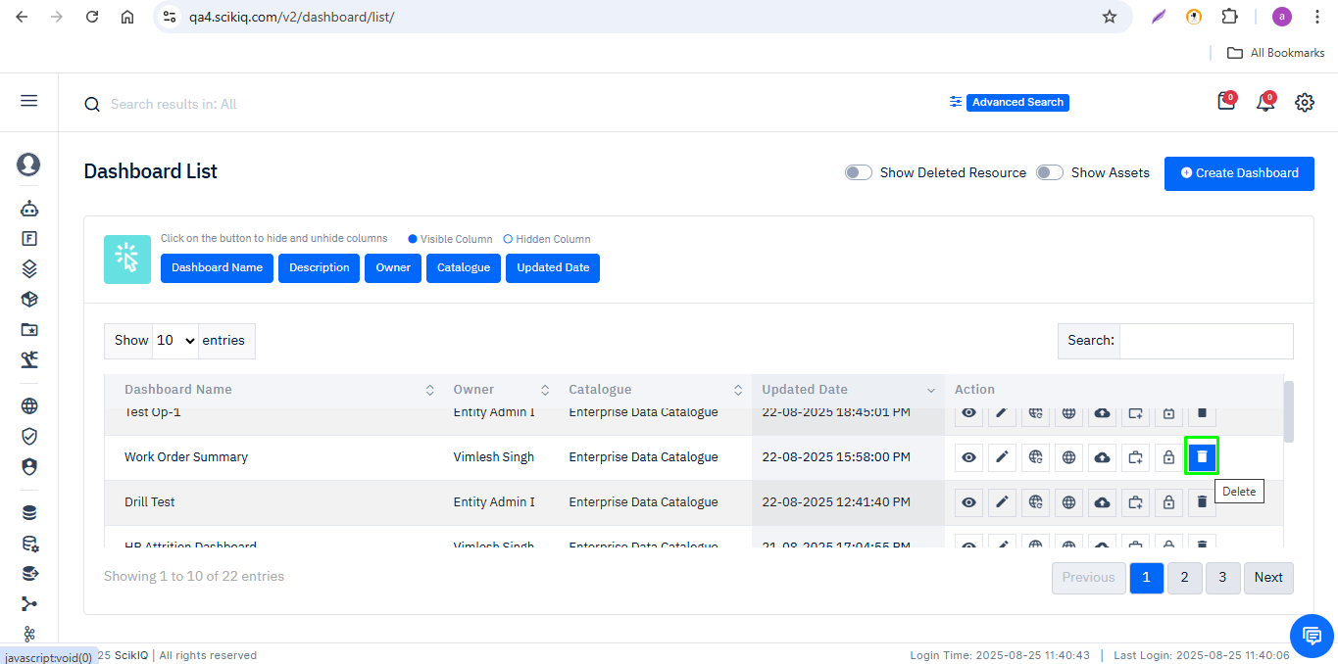

Step 3 :A confirmation prompt will appear: “Are you sure you want to delete?”
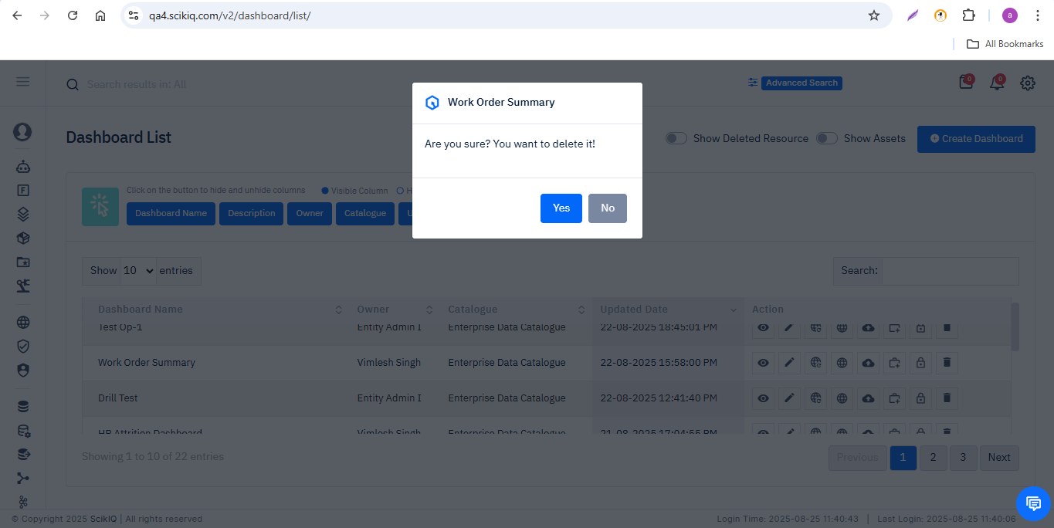
Step 5: Click Yes to confirm.
- The Dashboard will be removed from the active list.
- A flash message will appear: “SCIK-0173: Dashboard deleted successfully.”
- The total count of Dashboards will decrease.
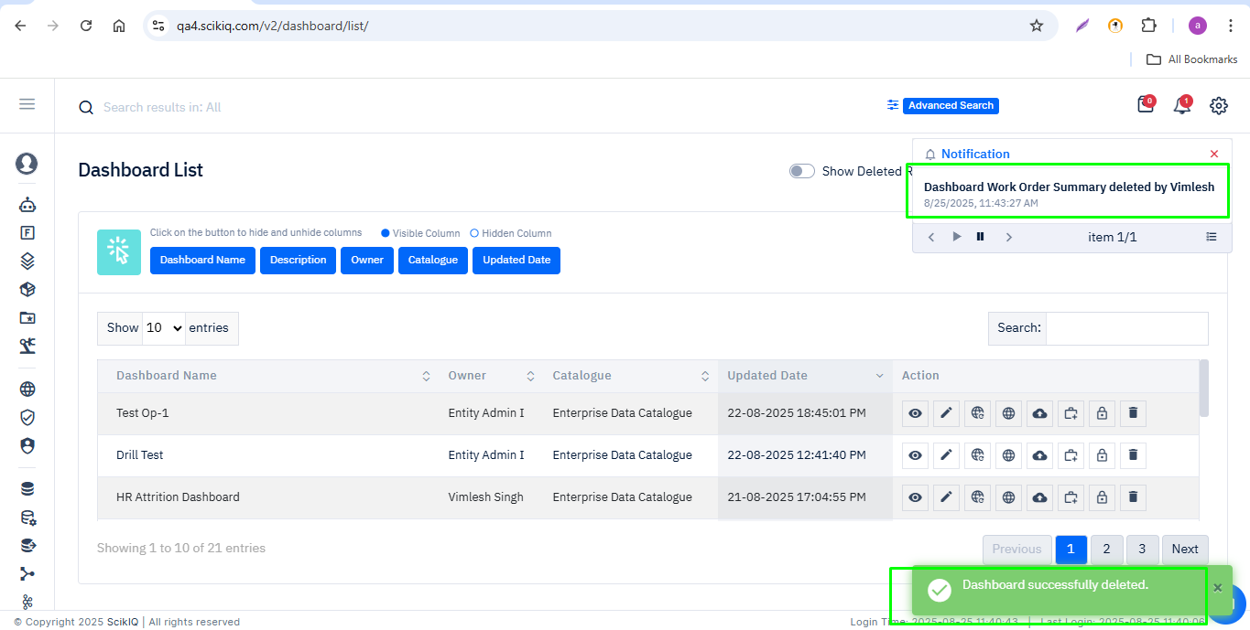

10.2 Display Deleted Dashboards
Step 1. On the resource listing page, enable the 'Show Deleted Resource' toggle
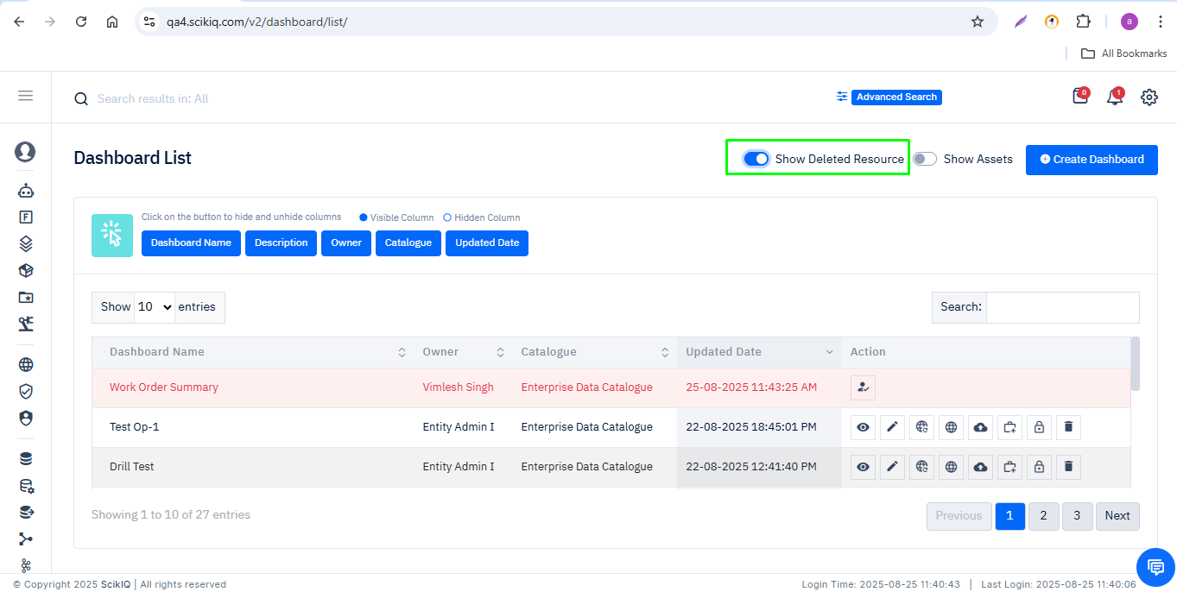
Step 2: Deleted resources will be visible in a distinct style (e.g highlighted in red).
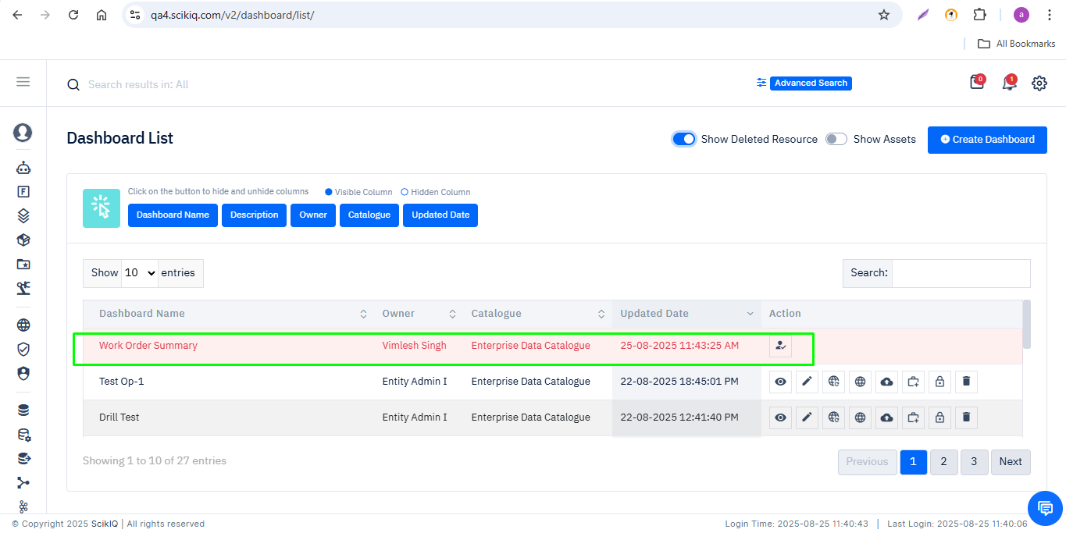

10.3 Restore Deleted Dashboard
Step 1: Locate the deleted Dashboard in the list.
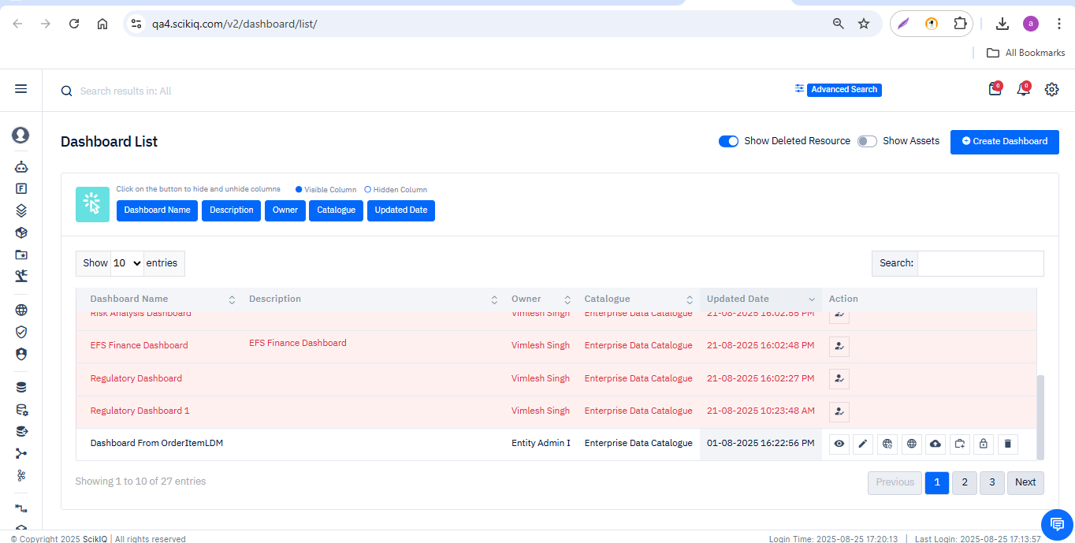
Step 2: Click the Restore/Reactivate button.
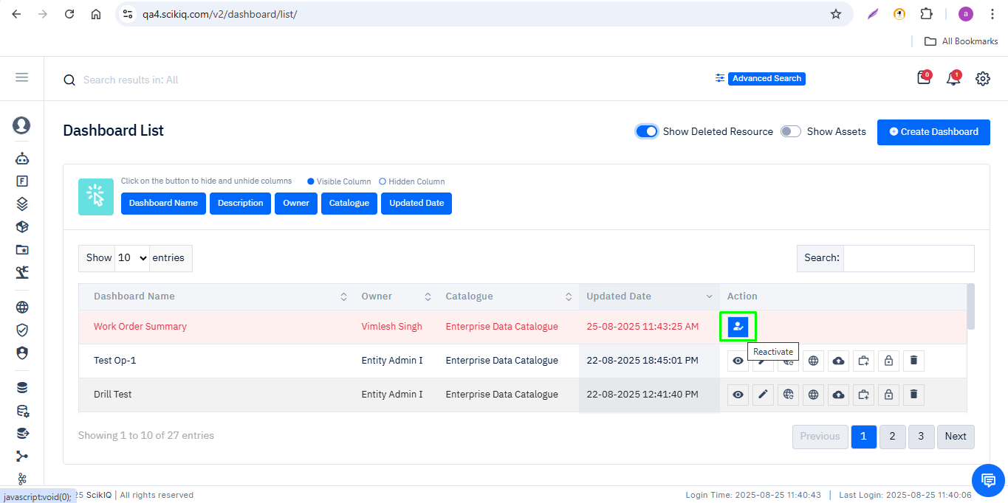

Step 3: Review the details and click Yes (or confirm) to proceed.
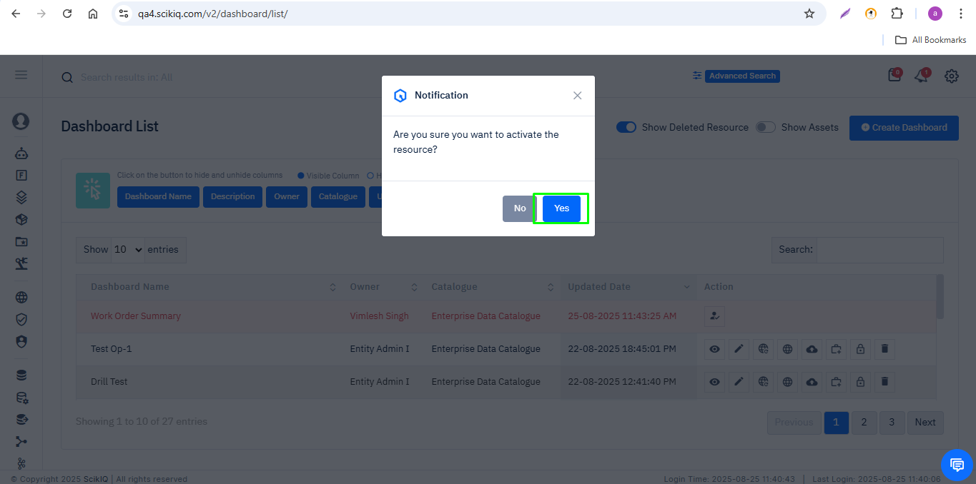
Step 4: A success notification will be displayed:
- Flash message: “Dashboard activated successfully.”
- A notification pop-up will also appear on the screen.
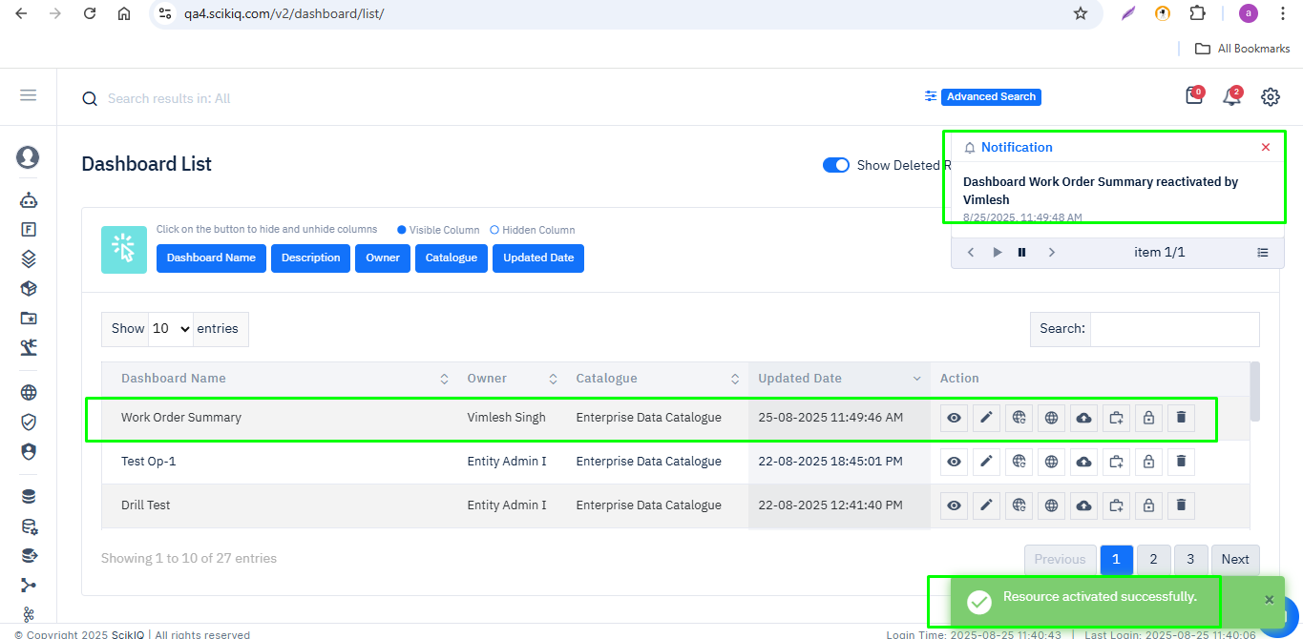
The restored Dashboard will now reappear in the active resource list. You can now use, edit, and configure it as required.

10.4 Special Considerations for Dashboard Restoration
- If the restored Dashboard has dependencies on other resources (such as datasets or LDMs), verify that those linked resources are also active and available.
- Review the Dashboard configuration to confirm visualizations and filters are correct.
- You may need to edit or revalidate the restored Dashboard for its intended business use.
- All restoration actions are logged for audit purposes. Only authorized roles may perform restoration.
- If the Dashboard was previously shared, then all permission granted will also be deleted for that you need to again defines as needed

11. Audit & Compliance
• All actions (delete, restore) are logged.
• Audit trails are available to authorized roles for compliance.
• Only authorized roles may perform restoration.

